**Manual for Household Listing Using Computers**

**in the DHS Surveys**

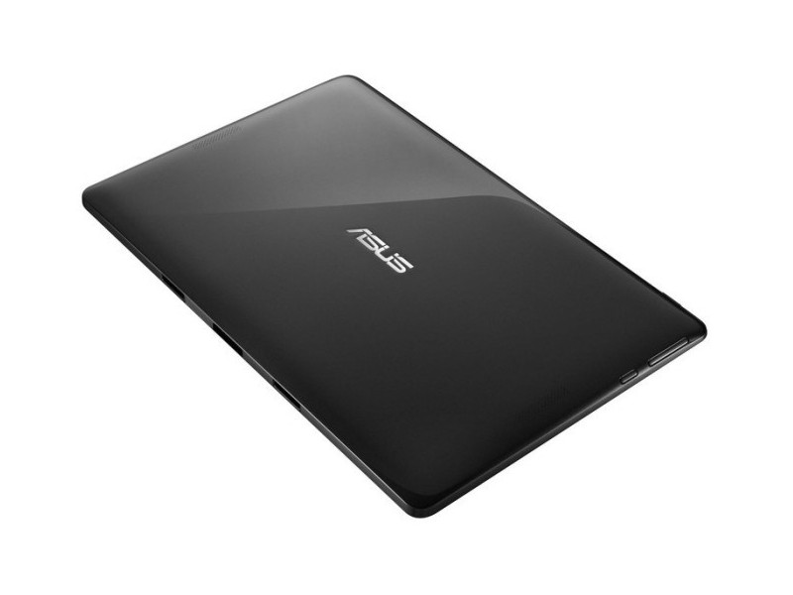

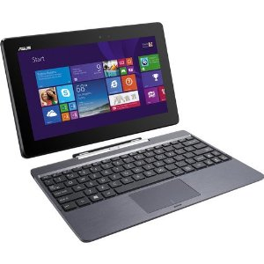

TABLE OF CONTENTS

[INTRODUCTION 4](#_Toc512445923)

[1. USING THE TABLET 5](#_Toc512445924)

[1.1 What is a Tablet? 5](#_Toc512445925)

[1.2 Powering up and powering down the Tablet 6](#_Toc512445926)

[1.2.1 Procedure for powering up (“booting”) the tablet 6](#_Toc512445927)

[1.2.2 Procedure for shutting down the tablet 7](#_Toc512445928)

[1.3 Working on Tablet in PC Mode 10](#_Toc512445929)

[1.4 Using the Electronic Keyboard 10](#_Toc512445930)

[1.5 Managing Batteries and Power with your Tablet 11](#_Toc512445931)

[2. ENUMERATORS CAPI MENU SYSTEM 13](#_Toc512445932)

[Glossary of Terms 13](#_Toc512445933)

[2.1 Introduction to CAPI Elements 13](#_Toc512445934)

[2.1.1 The Clusters File 14](#_Toc512445935)

[2.1.2 The Fieldwork Personnel File 14](#_Toc512445936)

[2.2 DHS Household Listing using CSPro 15](#_Toc512445937)

[2.2.1 CAPI Defined Buttons 16](#_Toc512445938)

[2.2.2 Area for Questions 17](#_Toc512445939)

[2.2.3 Data Capture Controls 17](#_Toc512445940)

[2.2.3.1 Radio Buttons 17](#_Toc512445941)

[2.2.3.2 Check Boxes 18](#_Toc512445942)

[2.2.3.3 Combo Boxes 18](#_Toc512445943)

[2.2.3.4 Text Boxes 19](#_Toc512445944)

[2.2.4 Field Definition Area 19](#_Toc512445945)

[2.2.5 Error Messages 20](#_Toc512445946)

[2.2.5.1 Errors that Need to be Corrected 20](#_Toc512445947)

[2.2.5.2 Warning Errors 21](#_Toc512445948)

[2.2.6 CSPro Status Bar Information 22](#_Toc512445949)

[3. STARTING THE HH LISTING MENU 24](#_Toc512445950)

[3.1 Step by Step Instructions for Starting the HH-Listing Menu 24](#_Toc512445951)

[3.2 Confirming Enumerator Codes and Cluster Number 26](#_Toc512445952)

[3.3 IFSS for the HH Listing Operation 27](#_Toc512445953)

[3.3.1 Description of Main HH Listing Menu 27](#_Toc512445954)

[3.3.2 Implementing Cluster Segmentation 28](#_Toc512445955)

[3.3.3 Register/Record Households in the Cluster 32](#_Toc512445956)

[3.3.3.1 Finalizing the Cluster Household Listing 36](#_Toc512445957)

[3.3.3.2 Making Data Back-ups 37](#_Toc512445958)

[3.3.4 Capture Cluster Coordinates 38](#_Toc512445959)

[3.3.5 Report of Households Listed in Cluster 41](#_Toc512445960)

[3.3.6 Change Cluster Number/Transfer Data to Central Office/Exist the System 42](#_Toc512445961)

[4. HH LISTING CENTRAL OFFICE SYSTEM 44](#_Toc512445962)

[4.1 Analysis of Incoming Files from the Field 44](#_Toc512445963)

[4.2 Status of Clusters Arrived in the Central Office 46](#_Toc512445964)

[4.3 Display/Receive Households Listed in Cluster 48](#_Toc512445965)

[4.4 Modify Households Listed in the Cluster 49](#_Toc512445966)

[4.5 Close Household Listing for Cluster 50](#_Toc512445967)

[4.6 Change Cluster Number 50](#_Toc512445968)

[4.7 Data Back-up 51](#_Toc512445969)

[4.8 Modify/Change: File/Cluster/Enumerator 51](#_Toc512445970)

[4.9 Report Missing Cluster/GPS/Not Reviewed 53](#_Toc512445971)

[4.10 Create Sample File of Households to be selected for the Survey 54](#_Toc512445972)

[4.11 Exit (Esc) 54](#_Toc512445973)

# INTRODUCTION

This document introduces the major components of the computer assisted personal interviews (CAPI) for Household Listing (HH-Listing) and for the Central Office System used in conjuction with the HH Listing operation. The document explains the role and responsibilities of enumerators as well as that of the Administrator of the Central Office system.

# 1. USING THE TABLET

## 1.1 What is a Tablet?

|  |
| --- |
| Figure 1: Using a Tablet  **touchl_7.jpg** |

Tablets are ultra-portable computers which can run a variety of software programs. For this survey, we use a system of programs developed using CSPro, which is a data entry and management software designed for surveys and censuses.

The tablets used for this operation receive input from users (interviewers, supervisors, enumerators) in a couple of ways: By using the hard keyboard provided with the tablet or by using a stylus on the tablet screen. When using the kleyboard the tablet behaves essentialy in the same way as a laptop or a PC computer. On the other hand, the stylus works in much the same way as a mouse on a conventional PC. Essentially, it can be used to click on the screen to control the actions on the tablet. On most tablets used by DHS the hard keyboard can be detached from the screen. However, for the HH Listing operation it is recommended to use the hard keyboard because this type of data collection requires a lot information to be typed. Essentially for each houshold the address and name of the household head is necessary to be enterd.

When using the stylus just apply gentle pressure on the tablet to select an option or to start the execution of an event or application. Do not apply excessive pressure on the screen with the stylus as it can damage the screen surface. Also, it is important not to press on the screen with the stylus for too long, since this will be treated by the tablet as a different command from that of a “click”. Normally, a single tap on the screen will be treated as the equivalent of a “left click” using a mouse, whereas to hold the stylus on the screen for more than a few seconds will be treated as a though it were a “right click” command using a mouse.

1. Power Button

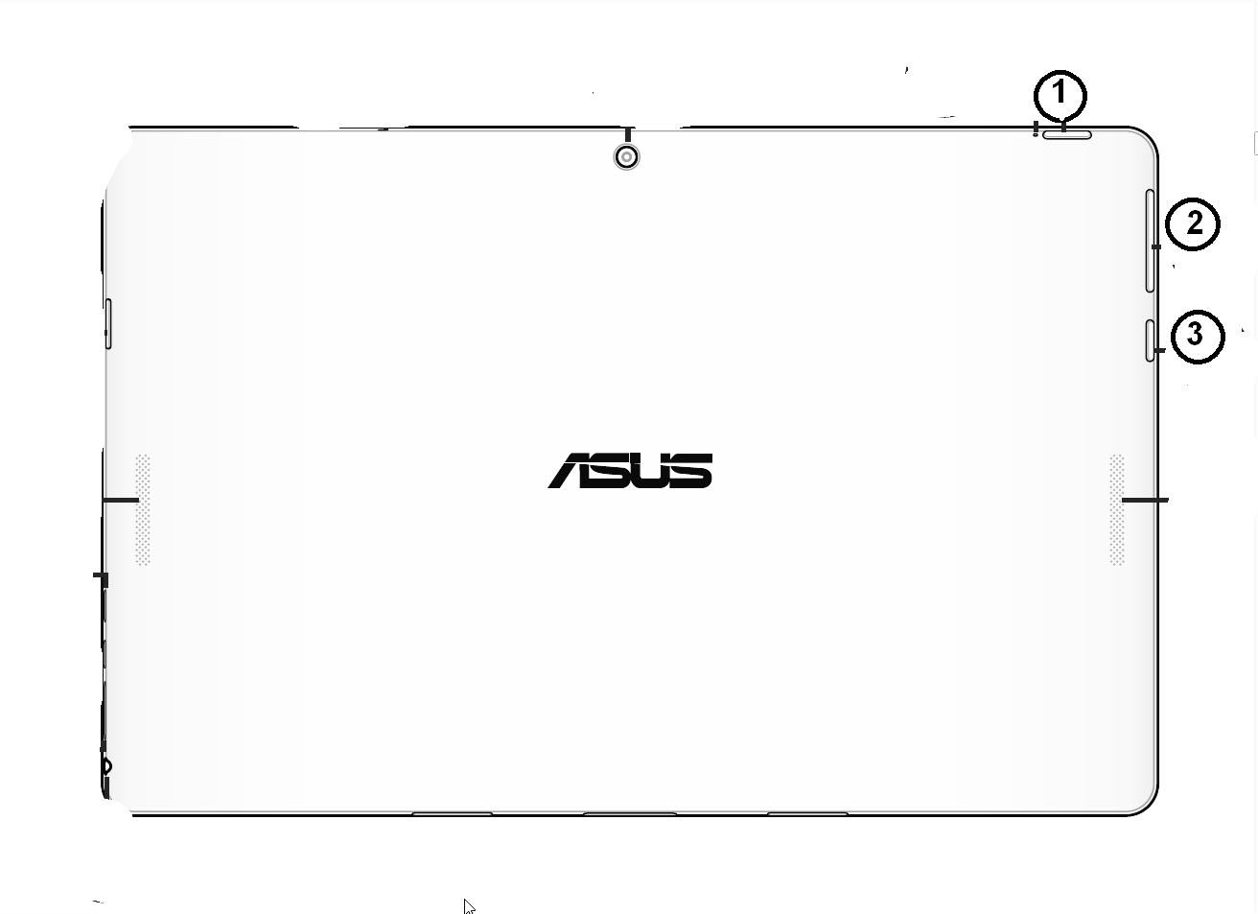

2. Windows Button

2. Volume control

## 1.2 Powering up and powering down the Tablet

### 1.2.1 Procedure for powering up (“booting”) the tablet

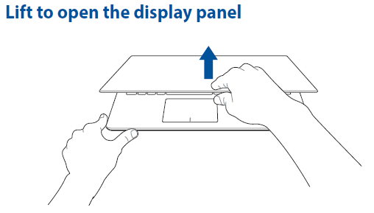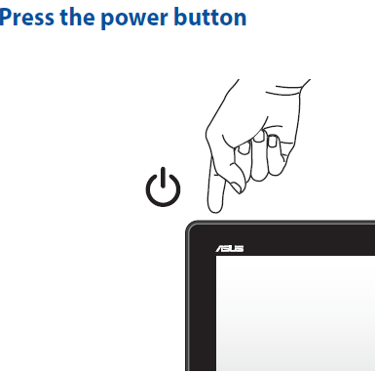

|  |  |
| --- | --- |
| windows-7-login-screen.jpg | 1. Icon for user  2. Password field  3. Electronic keyboard - letters  4. Electronic keyboard - numbers |

Follow the steps below to boot up the tablet and log in to your Windows User account.

1. Press on the Power button at the top right hand side of the screen, to power up the tablet.
2. With your stylus, click on the field titled “Password” and use the keyboard to enter your five digit password. This password will be given to you by the survey IT expert.
3. To login, click, on the right arrow icon to the right hand side of the password field, or click on the « Enter » button on the keyboard.
4. If your password is correctly entered, the Windows desktop will appear after a short delay.
5. If you see an error message, click on the password field and re-enter your password, making sure that you properly enter all password characters correctly. Then repeat step 5.

### 1.2.2 Procedure for shutting down the tablet

To shut down the tablet, the first step is to quit the CCDHS menu using the “Exit” option in the interviewers, supervisor or enumerators menu. Then, click on the Windows Menu button at the bottom left of the screen. The Windows Menu button is identified by the icon shown below.





Then, click on the power button next to the user name and a menu will appear with the following options.

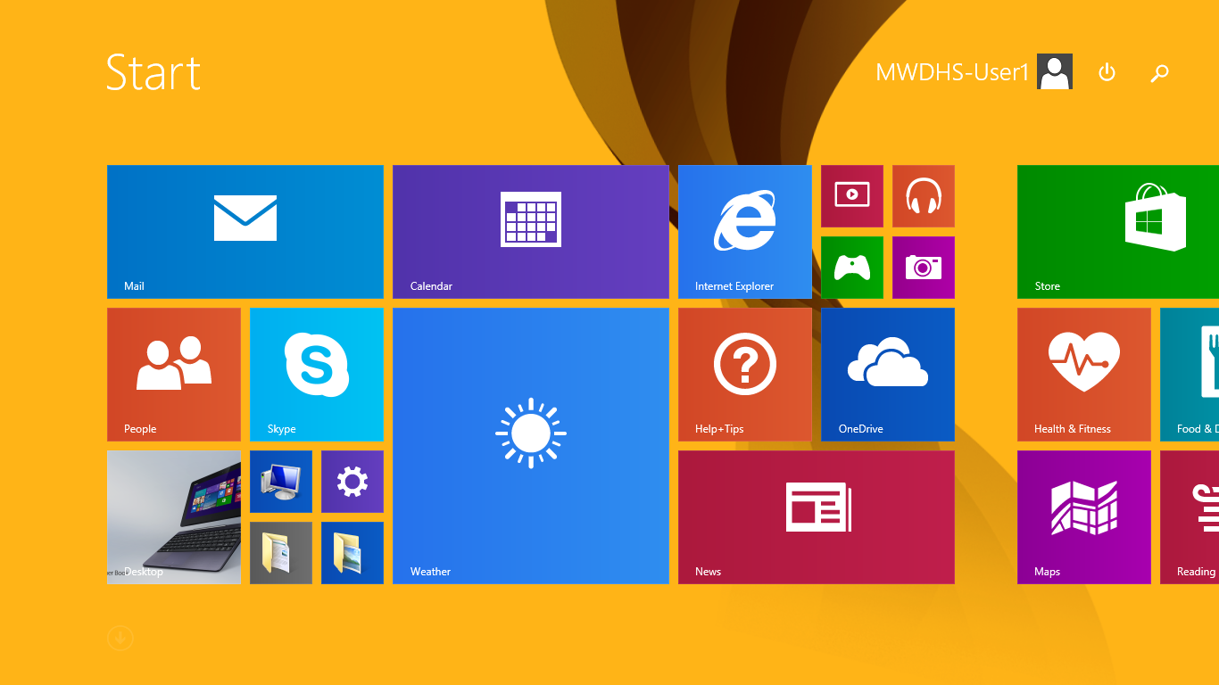

The tablet can be shut down in three ways:

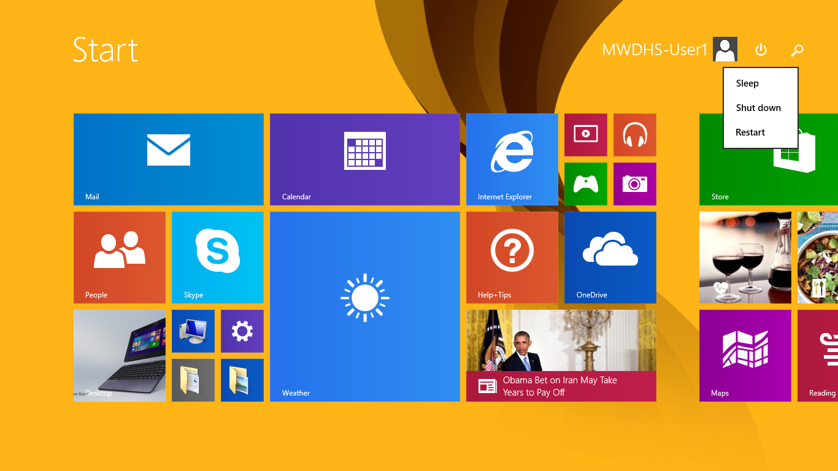

* 1. « **Sleep** » - this option puts the tablet into « sleep » mode, which means that the screen and hard disk are switched off but the tablet remains in a state that uses very little electricity.
  2. « **Hibernate** » - the tablet saves all the information about currently running programs in a file before it switches itself off. When the tablet is switched on again it will restore all windows and programs exactly as they were before the tablet was switched off. The main advantage of using this mode is that the tablet takes less time to boot up when restarting, and there is no need to restart programs that were running when the hibernate mode was used. The tablet does not use any electricity when it has been switched off using this mode.
  3. «**Shut Down**». The tablet will be completely switched off in this mode.
* **To conserve battery power, it is recommended that the “Sleep” mode be used to shut down the tablet if it is likely to be restarted within two hours (for example, during the day when carrying out interviews).**
* **If the tablet will not be used in the next two hours it is better to use the “Shut down” option.**

## 1.3 Working on Tablet in PC Mode

The tablet allows you to work in Tablet PC mode or as a regular laptop. To work in Tablet PC mode detach the table from the keyboard as follows:

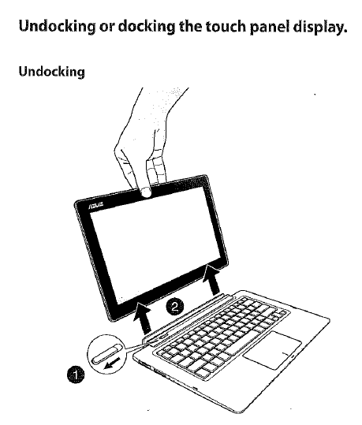

The Asus Tablet uses a stylus (like a pen) to control the netbook while in Tablet PC mode. This is similar to the use of the mouse while in regular PC mode. Use the stylus to click on the screen to record actions or instructions to the netbook. On the netbooks being used for the survey, it is necessary to press firmly with the stylus. The Tablet PC mode on the netbooks is made not to be too sensitive, so a light touch is often not sufficient to register the command. However, do not press the stylus too firmly, to avoid damaging the screen, and do not hold the stylus down on the screen too long as this will be viewed by the operating system as a different action than the one desired. For many things, clicking once on the netbook while in Tablet PC mode is like the left-click with the mouse while in regular PC mode, but holding the stylus down for a few moments while in Tablet PC mode is like right-clicking on a regular PC mode.

## 1.4 Using the Electronic Keyboard

When using the tablet for interviews, many responses can be recorded using the attached keyboard. However, in some situations you may want to enter numbers or text, using the electronic keyboard.

The electronic keyboard is a keyboard that is designed to be similar in layout to a physical PC keyboard. To access the electronic keyboard, click on the keyboard icon in the bottom right corner of the desktop.



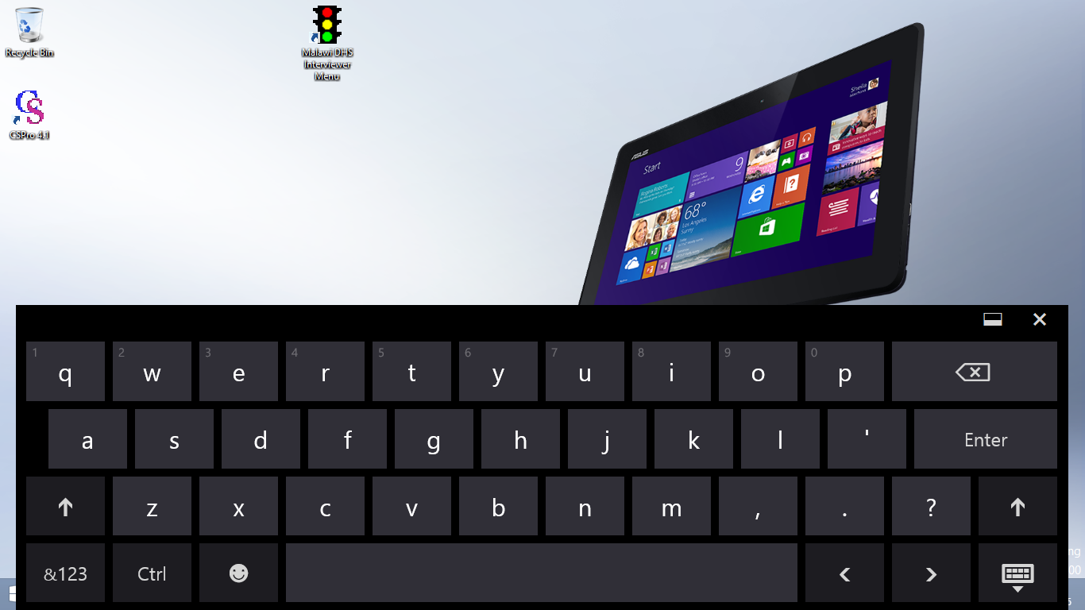

To enter a letter or a number, begin typing with your stylus or clicking with the touchpad on the area of the electronic keyboard corresponding to that letter or number. The system will then enter the character selected.

## 1.5 Managing Batteries and Power with your Tablet

To charge the battery in the tablet, connect the AC adaptor power cable.

A battery which is completely discharged will take about 2 hours to charge to 90% of its capacity, and approximately three hours to become fully charged. If the tablet is switched on and is being used while it is charging, it may take up to five hours for the battery to become fully charged.

You should charge the battery until the LED battery status light (described above) changes to blue, indicating that the battery is fully charged.

[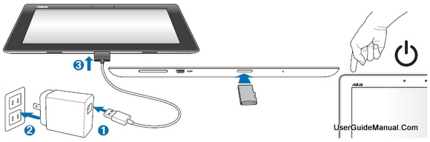](http://www.google.com/url?sa=i&rct=j&q=&esrc=s&source=images&cd=&cad=rja&uact=8&ved=0CAcQjRw&url=http://www.boeboer.com/asus-transformer-pad-tf300t-manual-user-guide-4g-lte-english-specs/&ei=a5SeVd7vAsn9tQXI-qOwBQ&bvm=bv.96952980,d.cGU&psig=AFQjCNFP--iYTq7VU8Hfv5jH3Ibhtjaz3Q&ust=1436542425310263)

[](http://www.google.com/url?sa=i&rct=j&q=&esrc=s&source=images&cd=&cad=rja&uact=8&ved=0CAcQjRxqFQoTCN-Bu-uk28YCFYuW2wodWWcA_A&url=http://www.gadgetguy.com.au/product/asus-transformer-book-t100/asus-transformer-book-t100-review-2013-10/&ei=y1mlVZ_wM4ut7gbZzoHgDw&bvm=bv.97653015,d.cWw&psig=AFQjCNHcvikxMEb_X87_xNxgdxtxBEOnvQ&ust=1436986174129785)

# 2. ENUMERATORS CAPI MENU SYSTEM

## Glossary of Terms

First of all let’s discuss certain terminology that is useful through this document:

**Application, program, system.** These are synonymous and they refer to CSPro programs, other utilities and in general functionality provided by CAPI.

**Supervisors, Interviewers, Enumerators or users.** Users are used indistinctly to refer to fieldwork personnel involved in the data collection operation. Sometimes the document explicitly refer to supervisors or interviewers but in some other the generic term users is used.

**Questions, fields, variables.** They are re used to refer to questions in the questionnaire or to areas in the computer screen where data is recorded.

**Rosters, multiple records.** Correspond to sections in the questionnaire that repeat. For example the household schedule where there is a line for every household member or the woman’s birth history where there is a line for every child the woman had given birth to.

**Cursor.** A cursor is an indicator used to show the current position for user interaction on a tablet screen that will respond to input from the input provided by users.

**Enter any key to continue**. In some specific fields the system prompts the user to: “Enter any key to continue”. Pressing any key works correctly, however it is recommended to use either the enter key or the space bar because those keys leave the field with a blank character.

**Computer, tablet, notebook, machine**. They are used indistinctively to refer to the device where the CAPI system is installed.

**Hard/soft Keyborads.** Certain brand or type of computers come with a hard keyborad attached to the screen. Sometimes the hard keyboard can be detached. In either case for certain fields it is necessary to key numbers or characters using the hard o soft keyboard. Keybords will be used to refer to either a hard or a soft keyboard indistinctively.

**Add/Modify mode**. These keywords refer to how CSPro interprets the data collection process. Essentially the first time that data is being entered CSPro is in add mode. When browsing through a questionnaire that was already completed CSPro is in modify mode. They are important because the CAPI system may not display some messages while in modify mode.

## 2.1 Introduction to CAPI Elements

DHS uses the Census and Survey Processing (CSPro) software for their HH-Listing operations and CAPI surveys. CSPro was developed by a partnership between the US Census Bureau and ICF. Before describing the CSPro functionality, let’s discuss two files or databases that are required to launch a DHS HH-Listing operation. These files are the backbone of the HH-Listing system as they allow enumerators to register into system, and to provide geographical information for enumerators to verify that they are listing the households in the correct cluster. The files need to be prepared well in advance before the data collection operation begins and these files are the clusters and the fieldwork personnel.

### 2.1.1 The Clusters File

This file contains one entry for every cluster included in the sample. It defines all geographical variables related to the cluster. The file contains the number of households in a cluster based on census data. This information is important to have an idea of how many households were present in the last census in the clusters. A typical clusters file has the following fields:

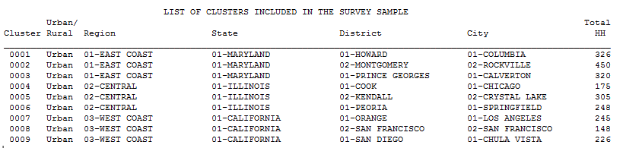

This file is normally used as a look-up table first to tell the HH-Listing system (as will be seen later) in what clusters the fieldwork team is collecting data. It is also used to assign the geographical variables needed to the data files.

### 2.1.2 The Fieldwork Personnel File

In this file enumerators participating in the HH-Listing operation are registered. Information like the name of the enumerator and the code assigned to every one of them are stored in this file. A typical fieldwork file looks like this:

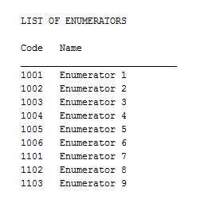

In the example above, the word enumerator is replaced by the actual enumerator’s name. The enumerator code along with the cluster number are used by the HH-Listing system to designate the names of data files where the information is stored.

## 2.2 DHS Household Listing using CSPro

CSPro has a programming language that allows to write logic to control and validate the information as it is entered. The data is entered in CSPro forms which can include one or a number of fields. A typical form along its different elements looks like this:

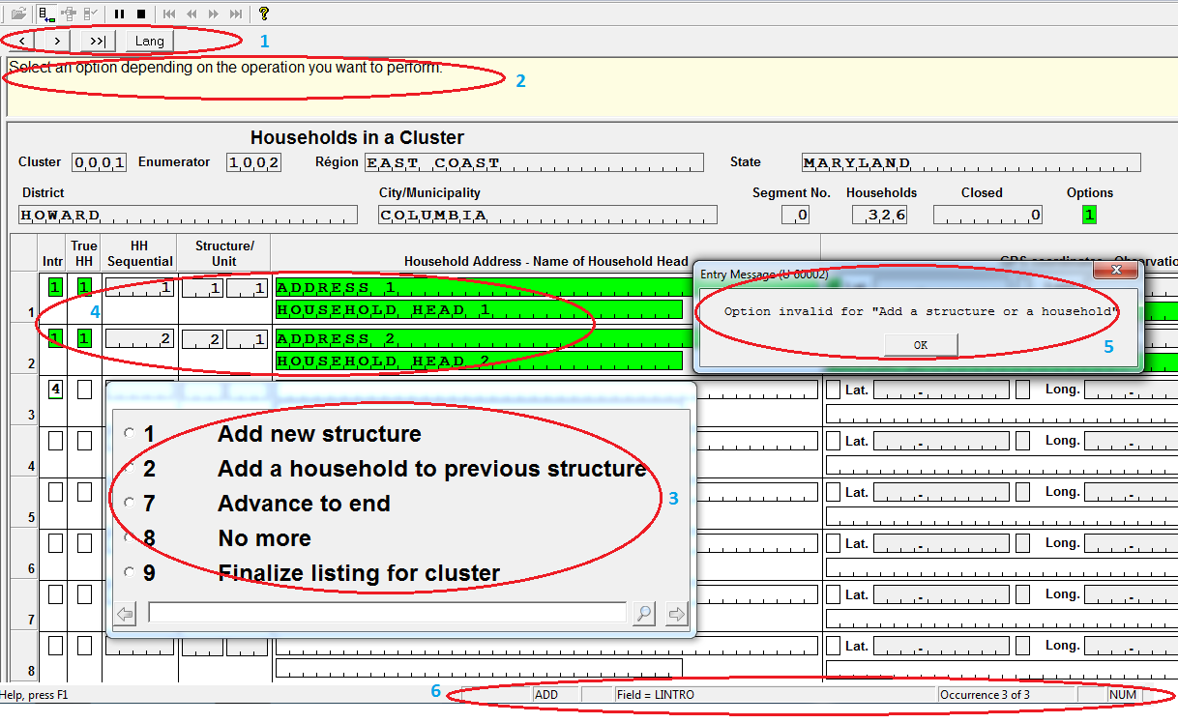

The elements in the form as numbered above are:

1. CAPI defined Buttons
2. Area for questions
3. Data capture controls
4. Fields definition area
5. Error messages
6. CSPro status bar information

Let’s discuss every one of these elements:

### 2.2.1 CAPI Defined Buttons

These buttons are used to navigate within questionnaire fields, to provide access to common used functionality or to provide an easy mean to display useful information to interviewers. The buttons may be different across forms, but the following are the most common buttons used by DHS.

 By pressing this button the cursor moves one field back. The button is also known as the “Back button”.

**** By pressing this button the cursor moves one field forward. The button is also known as the “Advance button”. It is important to note that CSPro doesn’t move forward unless some information is entered or is already present in the field where the cursor is placed.

 By pressing this button the cursor moves to the end of the questionnaire or the last field where information has been already entered. This button is very useful when reviewing or modifying information in a questionnaire because after modifications it is necessary to go to the end of the questionnaire. This button has the same functionality as the F10 key in the tablet keyboard.

 By pressing this button CSPro displays a window where interviewers can take notes related to the question where the cursor is placed or any note that interviewers deem important at any time during the data collection process. The window displayed by CSPro looks like the figure below. After typing the note users (enumerators) press the OK button to go back to the field where the note was taken.

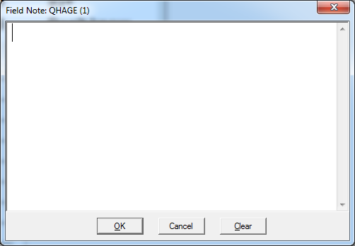

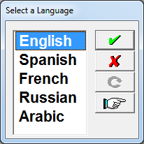 By pressing this button users can change the languages defined for the data collection operation. A window like the one on the right is displayed by CSPro after pressing this button. Users will highlight the desired language and click on the  button to select the highlighted language.

### 2.2.2 Area for Questions

This area is used by CSPro to display questions or instructions as the cursor moves from one field to another. The window is always placed on the top area of the screen. It is important that enumerators (users) read this area as it provides information on the type of data being requested for the field where the cursor is placed. It is possible that the text to be displayed in the area is too long and don’t fit in the window, consequently the scroll bar needs to be used to read the instructions properly. In some instances, the HH-Listing system customizes these instructions with information already being collected.

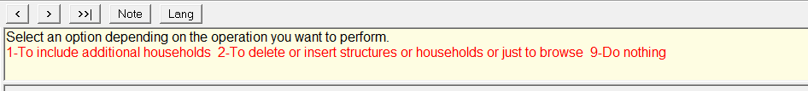

### 2.2.3 Data Capture Controls

When the cursor moves from one field to another, CSPro displays a window with the answers that are possible for that field. The window with valid responses is called a **“capture control”** and there are several types of them. CSPro knows what control to display depending on the characteristics of the field. There are several ways to enter information in a field depending on the type of device used to collect data as well as the type of control used. Enumerators can use their stylus if using a touch screen tablet, or they can type the code for the option to be selected either using the soft or hard keyboard. However, regardless of how the data is captured, users are required to confirm their selection by using the advance button defined earlier, or the advance button that is included in all controls (as shown below), or press the enter key in either keyboard. Sometimes the number of possible options don’t fit in the window where the control is displayed and in that case CSPro uses a scrolling bar on the side of the control. Users need to be aware of this characteristic as sometimes the answer given by respondents may not be visible and the scroll bar has to be used. In the current version of CSPro all controls come with a search box. This box is not designed to enter data, it is designed to search text in the categories available in the control. This characteristic is not used by DHS as most of the answers to questions are visible in the control. CSPro has the following controls available:

#### 2.2.3.1 Radio Buttons

This control is used when there is a predefined number of responses in a field and there are labels associated to every one of them. Users can only select one of the responses displayed by the control. The selected response is marked with a dot in the circle next to the selected button. Note that when selecting an option if a previous button was marked, the previous response is de-selected. A good number of fields in the HH-Listing system are of this type. All fields that use radio buttons in the HH-Listing system have numeric codes (values).

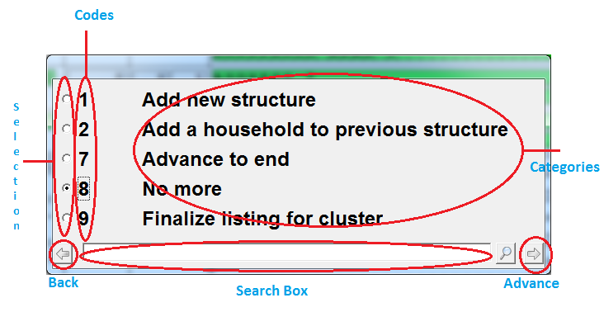

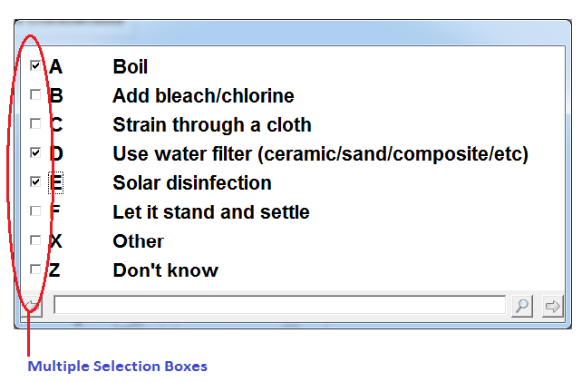

#### 2.2.3.2 Check Boxes

This control is used when there is a predefined number of responses (categories) to a question and there are labels associated to every one of them. In this case users can select one or more options. This type of control isn’t used by the HH-Listing system, but it is used extensible in DHS CAPI surveys.

#### 2.2.3.3 Combo Boxes

**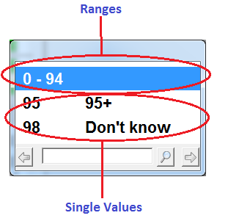**This control is used when the number of possible values in a field is too many to be displayed as a radio button. Rather than displaying one line for each possible value the combo box displays a range of valid values for the question. Sometimes there are special single values used in the control. This control is not used by the HH-Listing system, but it is also extensible used by DHS.

#### 2.2.3.4 Text Boxes

This is the simplest of the CSPro controls and it is used to enter plain text. In the HH-Listing system this control is used to enter names of head of households, addresses and also to record observations of the households being listed.

### 2.2.4 Field Definition Area

This is essentially a form as defined by CSPro. It is in forms where fields to be collected are placed. In the “Field Definition Area” is where the data is entered. Under special circumstances the control may lose focus and the data that is typed isn’t showed on the screen. In this case just click in the field where the cursor is expected to be and type the answer again. CSPro advances from one field to another in a pre-established path. The path is defined by the application developer and it corresponds to a pre-established logical way of collecting the data. As the cursor reaches a field a data capture control is displayed and information is expected to be entered. However, no control is displayed for fields defined as “Text Box” controls and instead the data should be typed in the corresponding field in the screen. When a form is displayed for the first time all the fields in the form are blank and once the cursor moves from one field to another the color of the field changes from blank to green. In the example below the cursor is under the column “True HH” and a selection of codes 1-yes or 2-No has to be made. Once the answer is confirmed the cursor moves to next field and the color changes from blank to green. In the HH-Listing system there are forms to capture the actual information relevant to households, the geographical coordinates (GPS), and the cluster segmentation when necessary.

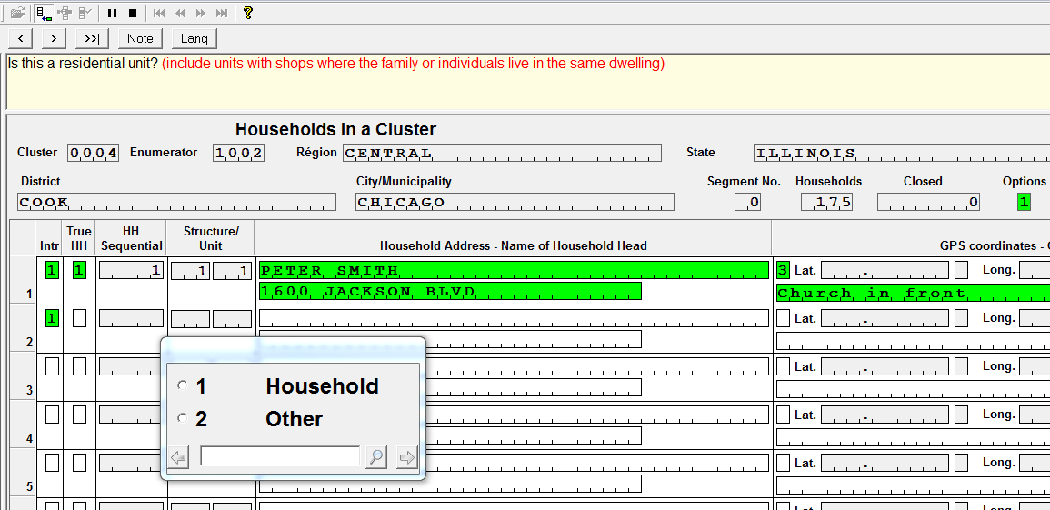

When users back-tab, field colors change from green to grey and the values stay in the fields. That way when moving forward again, CSPro remembers the values entered and users can move forward by just using the advance buttons or the enter key in the keyboard. If the form has already been populated (values were already entered in the form), users can use the stylus to quickly designate the field they wat to go to by just clicking on it. Finally, forms may have protected fields. Protected fields are populated by the CAPI system by either calculating, taking the information from the computer or importing the information from look-up tables.

In the screen above fields “HH Sequential” and “Structure Unit” are calculated by the system as enumerators enter household data. Information related to geographical variables such as region, State, District and so forth were obtained from a look-up table. Cluster and enumerator numbers were passed as parameters form the menu system that called the HH-Listing application. Enumerators don’t have access to protected fields and therefore those fields can’t be changed.

### 2.2.5 Error Messages

As mentioned earlier, CSPro checks automatically the possible values for every question. If a value for a question that is not valid is entered, CSPro displays the following message.

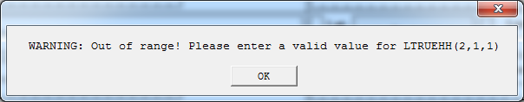

To dismiss the window message click on the OK button. After clicking OK the cursor stays in the field until a valid value (within the ranges) is entered.

The HH-Listing system also includes a number of consistency checks among questions. When the rules for the consistency check are not met, CSPro display an error message. There are two types of error messages.

#### 2.2.5.1 Errors that Need to be Corrected

This type of errors are critical to the data integrity and as result they need to be corrected. Example, the “Household address” should always be provided. If for some reason there is no address, enter information that help interviewers later to identify the household. In the figure below when the cursor was positioned in the field to enter the address, the enter key was pressed and therefore no address was provided.

**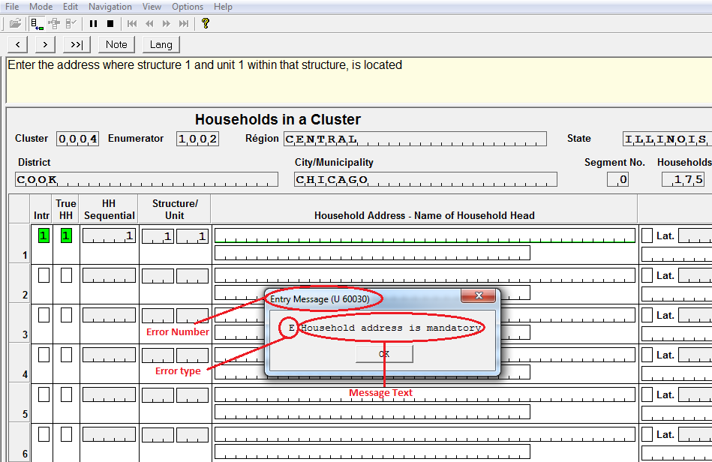**

The message window itself has three elements. The “Error number” is essentially a number given by the application developer. When asking questions about errors displayed by the HH-Listing system enumerators should refer to this number as it helps the developer to identify where the problem is located. The “Error type” identifies the severity of the error, errors that begin with the letter “E” indicate that they are serious errors that need to be resolved before the program proceed to the next question. The “Message text” is essentially a textual description of the problem. Users should read the text, use the information to identify the cause of the problem and provide a solution. Once the text is analyzed users should press the OK button. In this type of errors the cursor will stay in the field that originated the error until the problem is resolved.

#### 2.2.5.2 Warning Errors

This type of errors are normally inconsistencies that aren’t critical to the data integrity. However, interviewers should read and understand the message before dismissing it with the OK button. If after reading the error it is found that message was displayed as a result of a keying error, enumerators should go to the source of problem and fix it. The source of the problem isn’t necessary the current question but a previous question or questions that were used to establish the consistency with the current one. Messages that start with the letter W (Error type) are warnings. After dismissing the message with the OK button, the HH-Listing system continues with the following field.

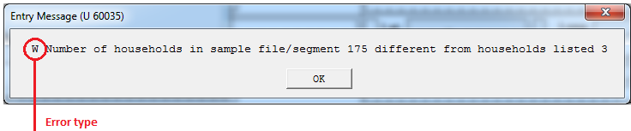

The error above is saying that the number of households for the cluster in the sample file (according to the last census) was 175, however the enumerator only found 3 households in the cluster. Although this is an extreme situtation, it is possible that the households in the cluster are not present anymore since the last census. This is possible as a result of natural disasters or other reasons. Consequently, the HH-Listing system allows the enumerator to proceed.

### 2.2.6 CSPro Status Bar Information

CSPro displays in the bottom of the screen in every form a status bar. This bar provides information that help enumerators to familiarize with the HH-Listing system. Most of the information

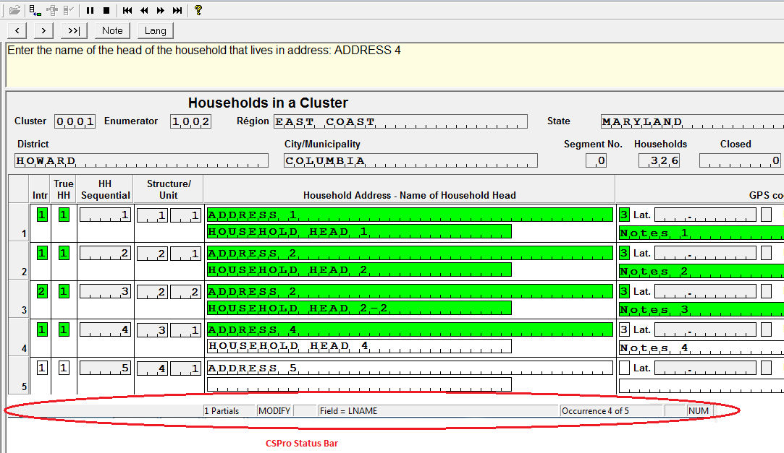

Most of the information included in the Status Bar is not critical for HH-Listing, but following is a description for documentation purposes. The first piece of information that the status bar provides is whether the clusters has been partially completed or not. “1 partials” means that the listing started in a previous session but was stopped and a new session is currently underway. The first time that the listing is carried out it shows the legend “No partial” in this area. The second piece of information tells whether CSPro is in ADD or MODIFY mode. In general, when collecting information CSPro is in ADD mode and when browsing through a form that was previously collected CSPro is in MODIFY mode. The Field = XXXX tells the user the name of the field where the cursor is currently positioned. In this example the status bar says that the cursor is positioned in field LNAME which corresponds to the “Name of the head of the household”. Occurrence N of M tells the user in what row or column in multiple records the cursor is positioned. In this example the cursor is currently positioned in occurrence 4 out of the 5 that have been collected so far. For single occurrence records it always says 1 of 1. Finally, CSPro tells whether the numeric key pad in the keyboard is on (NUM) or off (BLANK). The name of the field and the occurrence number are very important pieces of information when interviewers need to report problems they have identified while in the listing process.

# 3. STARTING THE HH LISTING MENU

## 3.1 Step by Step Instructions for Starting the HH-Listing Menu

To start the HH-listing menu, follow the steps shown below.

1. Make sure you are logged into Windows and are able to see the Windows Desktop on your tablet.
2. Double click on the HH listing data collection system icon on the Windows Desktop. The icon looks like a house and it has as its title text “HH Listing”. The start screen for the HH listing system is displayed after a few moments.

**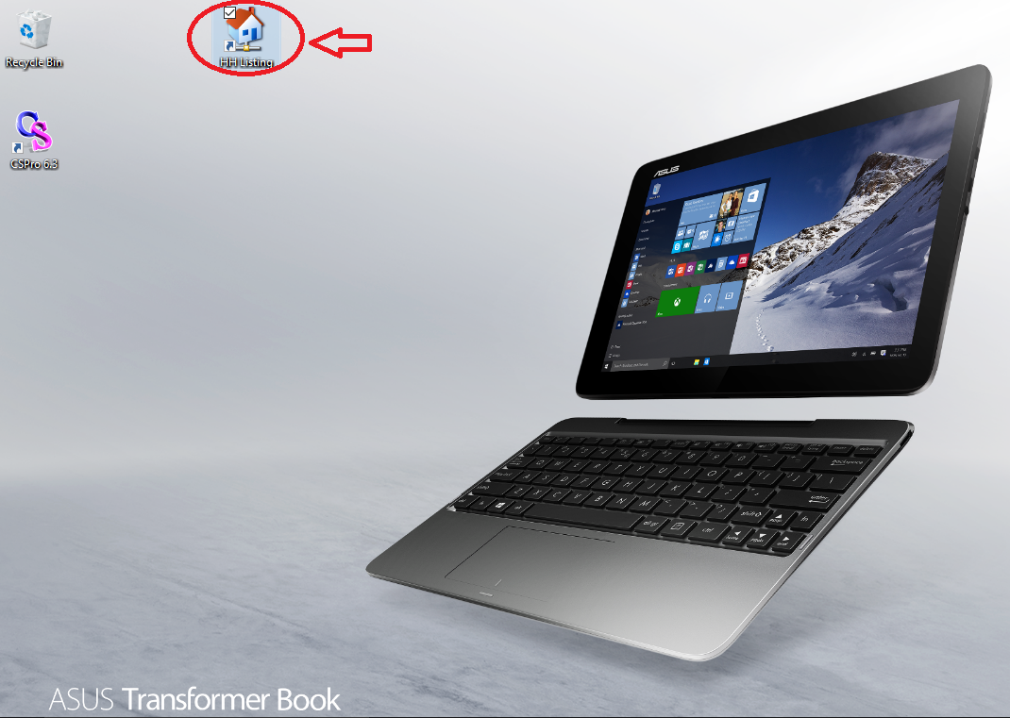**

The HH-Listing system will ask you to complete or confirm two important pieces of information for authentication purposes. These are, in the order that the system will ask for them:

1. Your enumerator code

2. The number of the cluster you are/will be working with

The cursor starts in the field with the label “Introduction” and in the area for questions a welcome introduction is displayed followed by an instruction to “Press any key to continue”. As recommended press the enter or space bar keys, the cursor will move to the enumerator field and will prompt you to select your name/code. To select your name, click on the small circle next to your name, you can also type your enumerator’s code number. The system then requests to enter the cluster number where you will be working. As described in the introduction the enumerator codes are stored in the “Fieldworker personnel” file and the valid clusters are stored in the “Clusters” file. By entering the cluster number, the system knows all geographical variables associated to the cluster.

Step by step this is how the information is requested:

1. The system asks to select your own name to identify you as the enumerator.

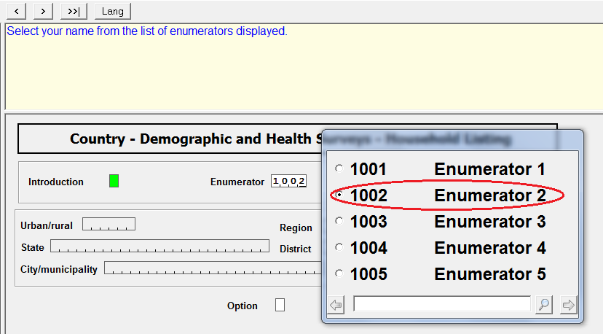

1. You will then be requested to enter the cluster number in which you are working; the cluster number has to be entered using the keyboard.

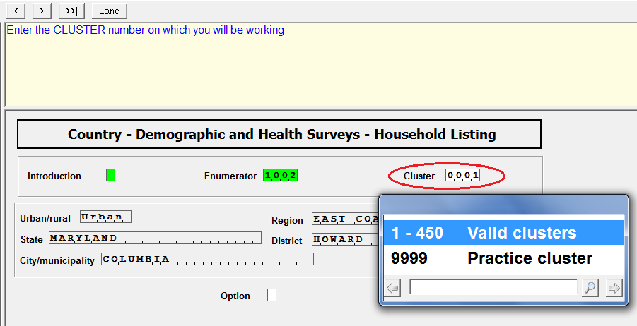

1. After entering the cluster number, the CAPI system displays the geographical variables associated to the cluster and the cursor moves to the “Option” field. At this point the system is ready to display the main menu for HH Listing.

Please make sure that the information provided in the area for questions (enumerator name and cluster number) is correct and that the geographical information displayed in the form corresponds to the cluster you are working in.

After the cursor reaches the option field it is waiting for you to press any key to display the main menu. Press the **next** button , or the enter key or the spacebar key on the keyboard and the Main Menu for the HH Listing system shows-up.

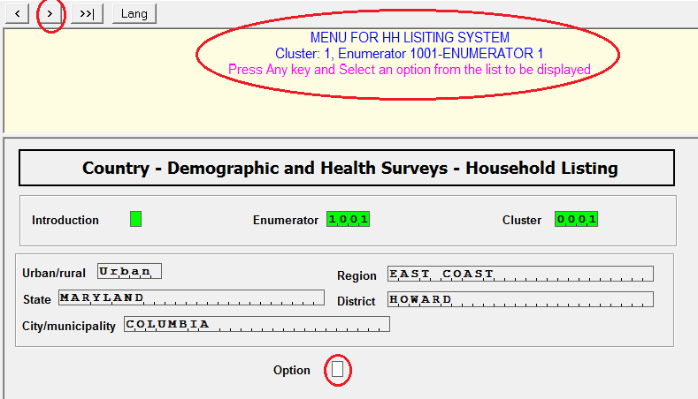

## 3.2 Confirming Enumerator Codes and Cluster Number

After the HH Listing system is executed for the first time, the system stores the enumerator code and the cluster number that is used for that data collection session. In subsequent executions of the system, it uploads that information and automatically prepopulate those fields with the known values used in the previous session. This is done for your convenience, to avoid the need to re-enter each of these items every time the menu is executed. However, you must **confirm** that each item is correct before continuing to the main menu. Special attention should be taken when moving from one cluster to another as the cluster number needs to be changed.

To confirm the enumerator code and cluster number, you can do either of the following actions:

- click on the button  at the top left hand of the screen

- use the “Enter” key on the keyboard.

Performing either action will confirm that the item is correct and the HH Listing system will move on to the next item.

|  |  |
| --- | --- |
| **C:\Users\21701\AppData\Local\Microsoft\Windows\Temporary Internet Files\Content.IE5\EM0L2KO6\MC900442128[1].png** | When starting work in a new cluster, make sure to **change** the cluster number to the new cluster where HH listing is about to take place. This is important as otherwise the households to be listed will be assigned incorrectly to a wrong cluster. |

## 3.3 IFSS for the HH Listing Operation

The HH Listing system is set-up in a way that it first access the Internet File Streaming System (IFSS). This is done to upload to the cloud any data collected by enumerators the day before. As can be seen when describing the Central Office system, this is the way to transfer data between the field and the central office. The DHS data processing expert will provide every enumerator with a user name and password to get access to IFSS.

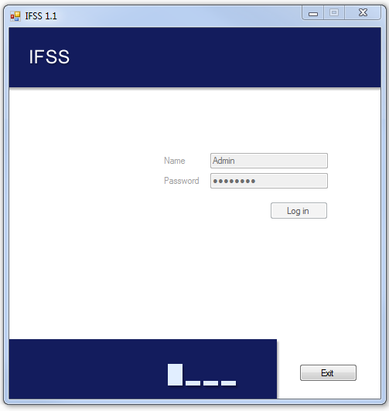

After IFSS uploads all data to the cloud (if available), the HH Listing executes the main menu to be described in the following sections.

### 3.3.1 Description of Main HH Listing Menu

The HH Listing system uses a main menu and a series of sub-menus to execute all possible tasks that are needed for enumerators to perform their work. All tasks are accessed through a *main menu*, either directly or through one of the sub-menus.

The main menu is used to access all tasks enumerators can perform. They include starting or modifying the list of households in the cluster, segmenting a cluster, taking the coordinates for the cluster, and sending data to the central office using the Internet File Streaming System (IFSS).

To choose a menu option, click on the option with the mouse, or use the stylus or your finger and select the option on the screen by tapping on it. The option can also be selected by typing the number on the left of the option. The up and down arrow keys can also be used to move between options and once the desired option is highlighted the enter key can be pressed to select that option.

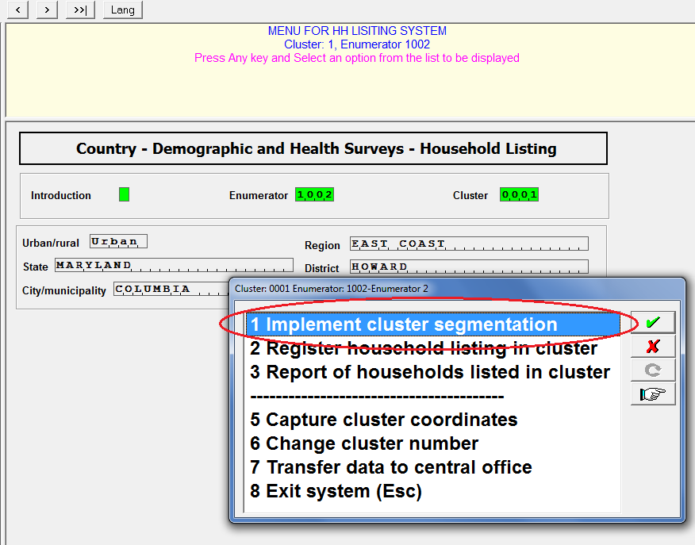

### 3.3.2 Implementing Cluster Segmentation

Upon arriving to a cluster enumerators have to decide whether the cluster needs to be segmented. (Please check the sampling manual). In general, DHS recommends that a cluster needs to be segmented if it is expected to have more than 300 households. If the decision is to segment the cluster, option **1** from the HH Listing main menu should be selected. After selecting option 1, the following screen is displayed.

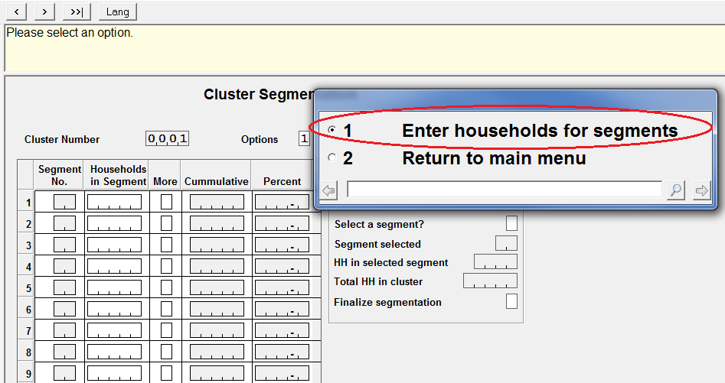

The cursor positions itself in the “Options” field and enumerators then have two options. Enumerators can go back to the main menu (option 2, if for example segmentation is not in fact needed) or they can start entering the number of estimated households for each segment. The system allows to segment a cluster in up to 20 different segments. The system does not allow to segment a cluster if households have already been entered in the household listing screen as will be described later. If households have already been entered, the error message below is displayed and essentially only option 2 to go back to the main menu is allowed.

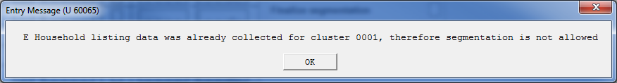

If no information for household listing have been entered/collected and option 1 is selected, enumerators are requested to enter the estimated number of households in each segment. After entering the number of households for each segment, the system asks if there are more segments in the cluster as shown in the figure below. Note that the system keeps the cumulative number of households for the cluster.

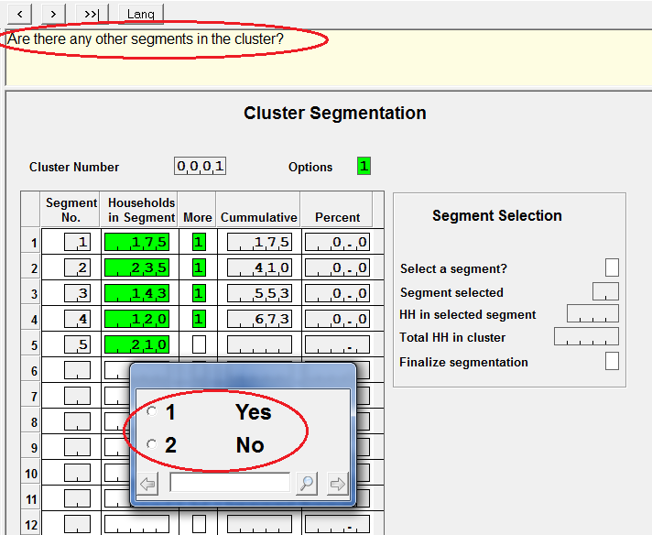

After households for all segments have been entered and enumerators indicate that there are no more segments in the cluster, the cursor moves to field “Select a segment?”. In that field, the system asks whether at this point the selection needs to be done. If the answer is “no”, all the information entered is discarded and the system goes back to the main menu. If the answer is yes, the system calculates the percentage of the cumulative number of households and randomly selects one of the segments as shown in the figure below. The system automatically populates the fields:

* Segment selected – This essentially indicates out of the many segments defined for the cluster randomly selected to be listed
* HH in the selected segment – This field indicates the number of households in the selected segment. It is expected that this will be the number of households to be listed as part of the household listing operation for the cluster
* Total HH in cluster – This field is important because it will be used in conjunction with the previous with the previous field to properly calculate the sample weight at the end of the survey.

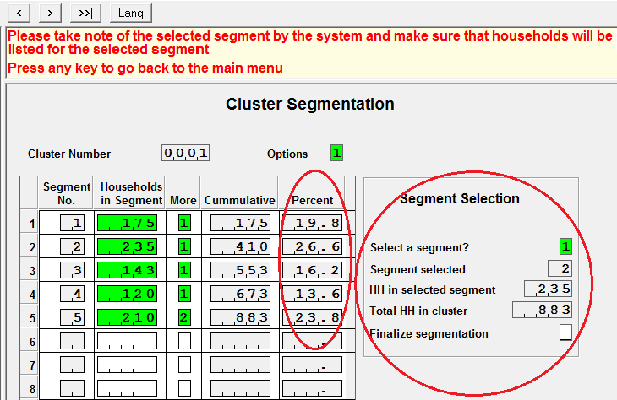

After the segment selection is done, the cursor moves to the field “Finalize the segmentation”. At this point a map sketch of the segment selected needs to be clearly marked. Read the message displayed in the questions area and press Enter or Space bar keys to continue. The system will return to the main menu.

If after the selection was completed option 1 of the main menu (Implement cluster segmentation) is selected again, it is because two reasons. The first one is just to browse the segment composition, if that is the case, then in the Cluster Segmentation form option 2 is selected (Return to main men) and no action is taken by the system. The second option is to change either the number of households in any segment or add more segments. In that case, the system displays the following warnings:

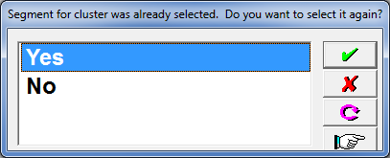

If the answer for this warning is “No”, the system returns back to the main menu and the no action is taken. If on the contrary the answer is “Yes”, the system displays the following message. Even after dismissing this message if the number of households in each segment do not change and if there are no new segments, the random selection does not change.

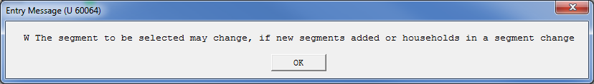

In any case none of these options are allowed if data has already been collected the for the HH Listing operation.

### 3.3.3 Register/Record Households in the Cluster

If no segmentation is necessary or after the segmentation is completed, enumerators proceed to register the households identified in the cluster. To do that use option 2 of the main menu.

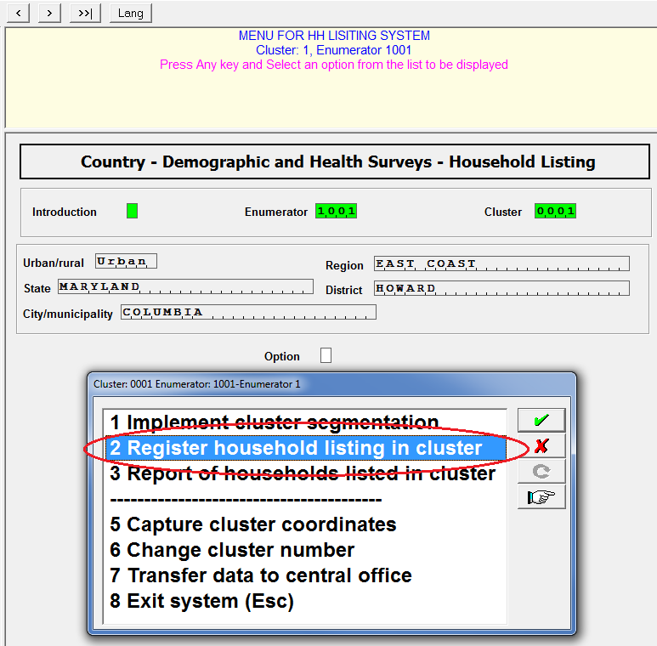

Once option 2 of the main menu is selected, the system displays a form to register the households to be included in the cluster. Essentially the form includes several pre-populated fields that help enumerators to identify that they are in the correct cluster as well as a roster to register all structures and households that are part of the cluster.

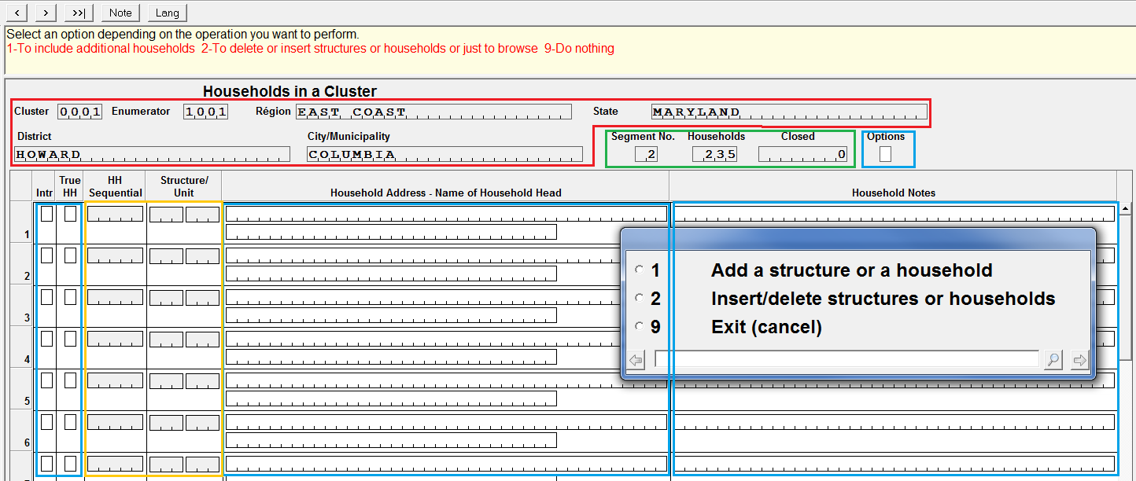

The form has the following type of fields:

* Circled in red are geographical fields populated automatically by the system. The information for these fields comes from the clusters file and they are specific for the survey. It is important that enumerators review and verify that those fields correctly describe the cluster where the listing is about to take place.
* Circled in green are the fields: “Segment No.”, number of “Households”, and date when the cluster is “Closed”.
  + The segment field has the number of the segment in the cluster to be listed. If the cluster is not segmented, this field has a value of zero. If the cluster is segmented, the field has the number of the segment randomly selected by the segmentation algorithm.
  + The “Households” field has the number of expected households to be listed for the cluster. If the cluster is not segmented, the number of households are those provided from the latest census data and the value is coming from the clusters file. If the cluster is segmented, the number of households correspond to the number of households in the segment that was randomly selected by the system.
  + The closed field contains the date when the HH Listing operation for the cluster is completed. The filed starts with a value of zero and when the enumerator decides that that all households have been listed, it populates that field with the date when that decision was taken
* Circled in blue are fields where enumerators provide input to the system. The fields in blue are: Options, Intro (Introduction), True HH, HH address and name of the household head and household notes.
  + After displaying the form “Households in a Cluster”, the system populates the previously described fields and the cursor positions itself in the options field. At that point the system displays a window with the options:

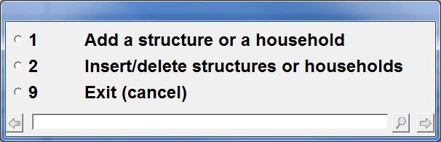

Enumerators essentially can add structures or households (option 1). Insert structures or households in previously recorded households or structures (option 2) or simply exit the form with no modifications (option 9). Most of the times enumerators use option 1 to add structures or households. The first time that this option is selected the cursor moves to row 1 in the roster. When this option is used after some households are already registered the cursor moves to the next row in blank in the roster in order to be able to record new households. Inserting households or structures are necessary when one of them were missing.

* + The **Intr** (Introduction) column in the roster is critical because it is used to instruct the system on the type of dwelling units or households that are about to be registered. When the cursor reaches this field, it displays some tasks that can be performed considering the type of task requested in the previous item. If in the previous item option 1 “**add a structure or a household**”, was selected, the system displays the following window.

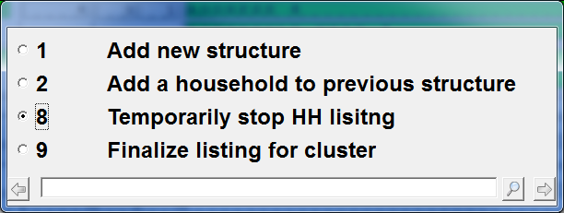

Option 1 (**Add a new structure**) is used to essentially register new dwelling units. Option 2 (**Add a household to a previous structure**) is used when in the same dwelling unit there are more than one household. This option is also used for apartment buildings, but can also be used for single units when more than one household live in it. Option 8 (**Temporarily stop HH listing**) is used to stop the cluster HH Listing with the intention of resuming the work at a later time. Option 9 (**Finalize listing for cluster**) is used after having recorded all households in the cluster. When this option is used, the system populates the “Closed” field circled in green at the top of the form with the date when the option was used.

If on the contrary in the previous item option 2 “**Insert/delete structures or households**” was selected, the system displays the following window.

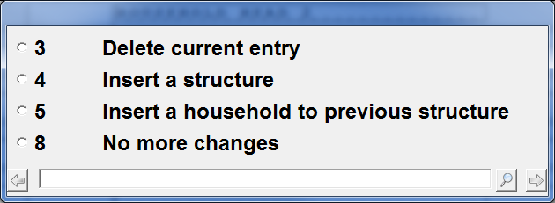

Option 3 (**Delete current entry**) is used to delete from the roster the occurrence where the cursor is placed in the Intr field. Option 4 (**Insert a structure**) is used when the enumerator by mistake skipped one dwelling unit. Option 5 (**Insert a household to previous structure**) is used when it is found that another household is living in a dwelling unit after registering another dwelling unit. This is necessary because the order in which households are registered in the cluster for the HH Listing operation is important for sampling selection of households. After completing all changes made as part of the process of inserting/deleting structures or households, option 8 (**No more changes**) should be used.

* + The **True HH** column of the roster is used to define whether the structure to be included in the HH Listing is in fact a household or not. When the cursor reaches this field, it requests from the enumerators to select whether this is a residential unit or not.

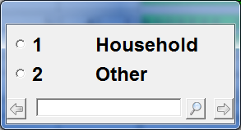

Based on HH Listing methodology it is important to list all structures like churches, shops, supermarkets, etc. However, if the unit is not occupied by a household it will not be included as part of the household selection.

* + The column **Household Address – Name of Household Head** in the roster, are used to register the address of the household and the name of the head of the household. These fields are mandatory and enumerators should make any effort possible to get both of them. If for some reason there is not an address associated to the dwelling unit, enumerators should just write some description that help later to identify the household. If the name is not available, just right something like “Name could not be obtained”.
  + The column **Household Notes** in the roster is an optional filed used to register any comment about the household that enumerators find relevant related to the household. Enumerators are encouraged to use this field extensible to provide any information that may help later to identify the household. Actually, at any point in the process of the household operation, enumerators can use the  button to take any notes that they consider important.
* Circled in yellow are the roster fields **HH Sequential** and **Structure/Unit.** These fields are reserved and populated automatically by the HH Listing system. The HH Sequential field is used to assign a sequential number to every household listed. This field is left in blank (not applicable) if the field **HH True** specifies that the unit is a non-residential unit (other). The fields Structure/unit define separate dwelling units (structures). A structure can have several households living in them. For example, an apartment building with a common entrance door but multiple apartments inside. As soon as the system assigns the HH sequential and Structure/unit numbers, the mapper should mark that unit in the map.

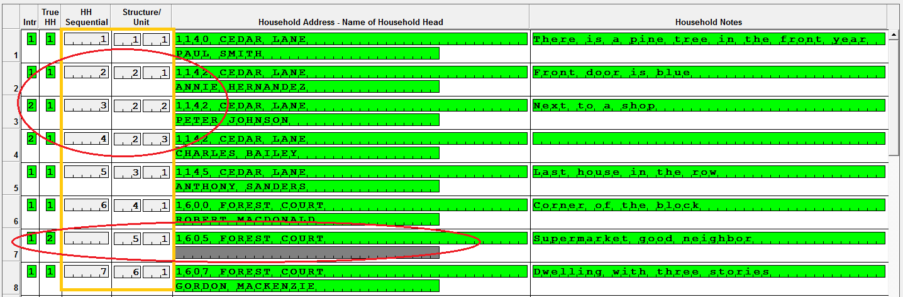

Note that in the figure above households 2, 3 and 4 belong to the same structure 2. Consequently, the units within the structure are numbered 1, 2, 3. It is also important to note that structure 5 is not a household (True HH is 2) therefore, no HH sequential number is assigned and the name of the household head is skipped.

#### 3.3.3.1 Finalizing the Cluster Household Listing

At some point after enumerators go through all households in the cluster, they should declare that the listing operation for the cluster is completed. In order to do that when the cursor reaches the **Intr** field after the last household listed, enumerators should select option 9. It is important to note that his option is only available as part of option 1 in the introduction (Add structure or a household).

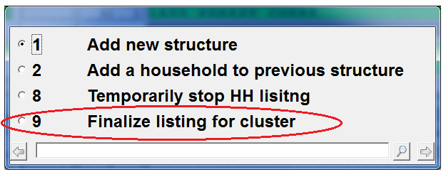

Once this option is selected, the system compares the number of households listed with those coming from either the census data or the segmentation procedure (as described before). If the number of households listed are not within 30% of the households expected, the message shown below is displayed. Finalizing a cluster at the right time is important because that helps the central office to know when enumerators declared the cluster closed.

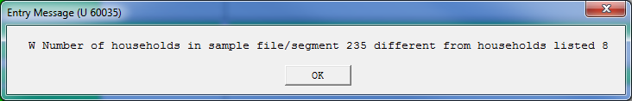

Finally, the system displays the message:

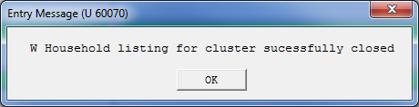

Nevertheless, it is important to note that even after a cluster is declared as finalized, enumerators can add or modify the household listing roster. However, when doing that the system displays the message below and they have to take an action accordingly.

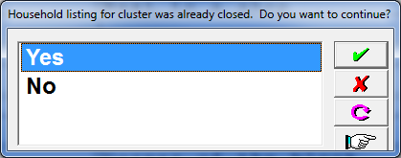

#### 3.3.3.2 Making Data Back-ups

Every time that enumerators get out of the screen with the roster to register households, the system automatically saves the data to the tablet’s hard drive. However, to avoid any data loses it is also important to back-up the data to external devices. Enumerators are provided with flash memory devices for that purpose. After leaving the HH Listing roster, the system prompts to have the flash memory attached to the tablet with the following message:

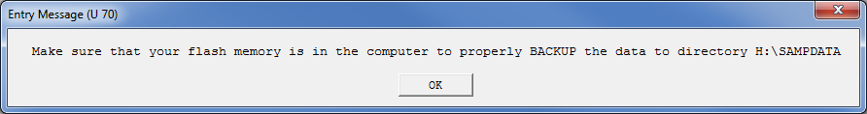

If after dismissing the message the flash memory is not still attached to the tablet, the system displays the following message

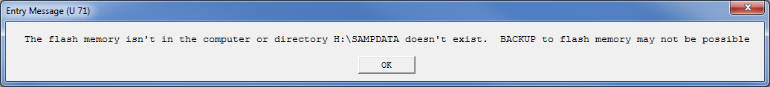

If necessary, go back to the HH Listing roster and come back to the main menu making sure that this time the flash memory is attached to the tablet.

### 3.3.4 Capture Cluster Coordinates

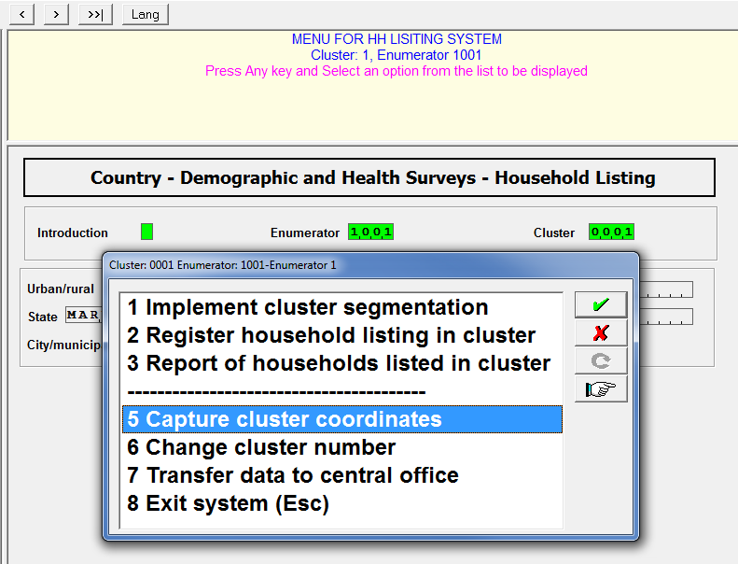

Option 5 from the main menu is used to capture cluster coordinates. Before selecting this option, enumerators have to make sure that the GPS Dongle is inserted in the tablet. After this option is selected, the HH Listing system displays the following form to capture the coordinates.

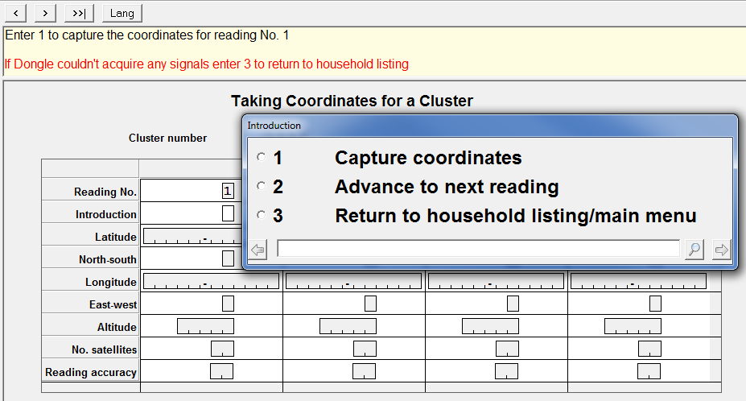

Essentially, this form is provided to capture a set of coordinates at the center of the cluster. However, the form allows to take up to 4 measurements in each cluster. The rational is that if for some reason it is not possible to go to the center of the cluster, enumerators can take coordinates at the extremes of the cluster. Later on theses coordinates are averaged to produce the cluster geometrical center. The figure below shows three different shapes of clusters and possible spots where the coordinates can be taken to get the center of the cluster. However, if the enumerator can go to the center of cluster the coordinates can be taken at that spot. Even in this case it is recommended to take at least two measurements a couple of steps apart.

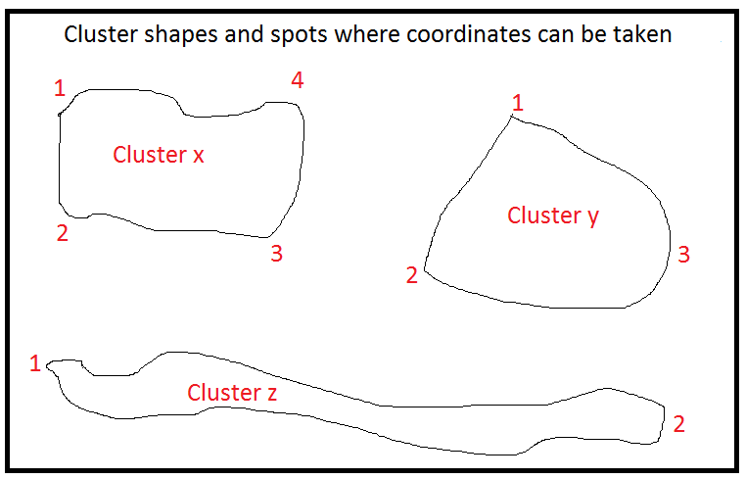

The first time that the form to take coordinates is displayed, the cursor positions itself in the first column ready to take the first set of coordinates. In order to do that, enumerators select option 1 (Capture coordinates).

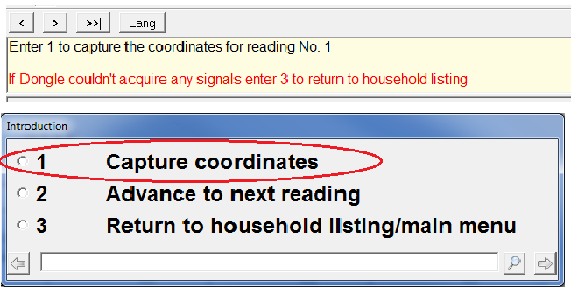

At that point, all relevant fields to the place where the enumerator is standing will be populated by the system. Latitude and longitude are coordinates in degrees. Altitude are the number of meters above sea level of the reading. Satellites is the number of satellites used to determine the coordinates. Generally, the greater the number of satellites, the better the quality of the reading. Reading accuracy determines the precision of the reading. An accuracy value of 1 is the most accurate and 50 is the least accurate. For latitude and longitude, the system will determine whether the place is located to the north (N)/south(S) of the equator or east (E)/west (W) of the Greenwich meridian. Enumerators should have a sense of the country coordinates in order to be able to make a quick check of the coordinates being captured. For example, all clusters in Colombia should be located between latitudes 4.5 South and 13.0 North and longitudes 66.0 and 79.0 West (with some islands outside these limits). After taken the first reading, the system positions by itself in the second column ready for a second reading. If the second reading will be taken at a later time, then option 3 to return to the main menu should be selected. By doing that, the coordinates are properly saved.

If at a later time a second, third, or fourth reading is necessary, enumerators should select again option 5 form the main menu (Capture coordinates). At that point, the HH Listing displays the form with the coordinates previously captured. If it is decided that the coordinates are not going to be taken at this point, select option 3 (Return to household listing/main menu) and no action will be taken by the system. This characteristic can be used to check just the coordinates that have been so far taken. In the figure below, three sets of coordinates have been taken and a fourth one can be captured. To go to the fourth column, select option 2 (Advance to the next reading). The cursor positions in the introduction field of the fourth column. Once there select option 1 to capture the fourth reading. After completing the fourth reading, the system will return to the main menu. If it is the second or third reading that took place, the system will position in the third or fourth column ready for another reading. Again at that point, option 3 can be used if no more readings are necessary at that time.

It is also possible to override any of the readings. This is not recommended, but if the number of satellites is only one or two, or the reading accuracy is greater than say 20. It is up to the enumerators to decide to replace the reading. In order to do that immediately after displaying the form select option 2 (Advance to the next reading) and after that using the mouse or by back tabbing go to the column that needs to be override and select option 1 (Capture coordinates). New coordinates will replace the former ones.

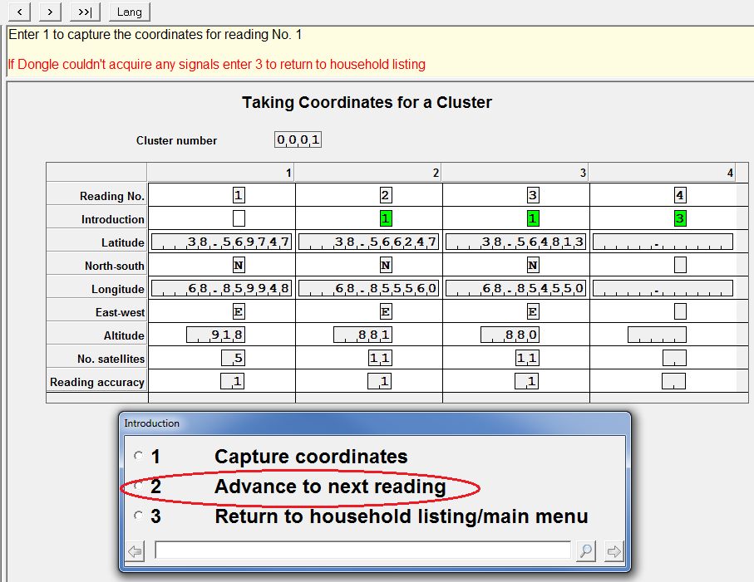

### 3.3.5 Report of Households Listed in Cluster

Option 3 of the main menu is designed to help enumerators check the status of the household listing operation in the cluster. This report can be produced at any time during the listing process.

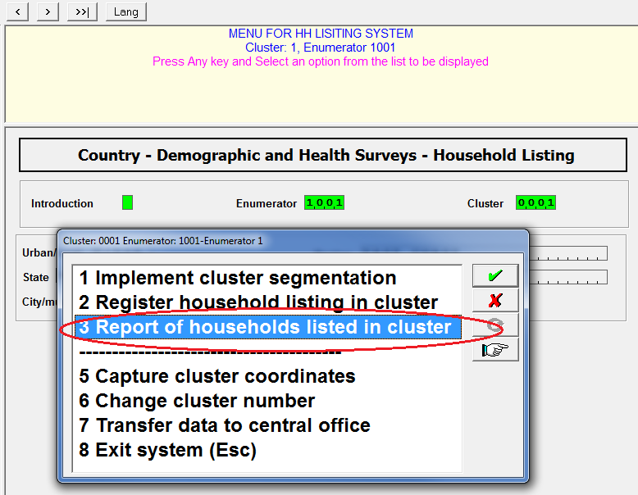

The report essentially shows all information collected as part of the household listing operation. The report is divided into three major components: Households registered into the system at the time producing the report, segmentation when relevant, and GPS coordinates if they have already been collected at the time of producing the report.

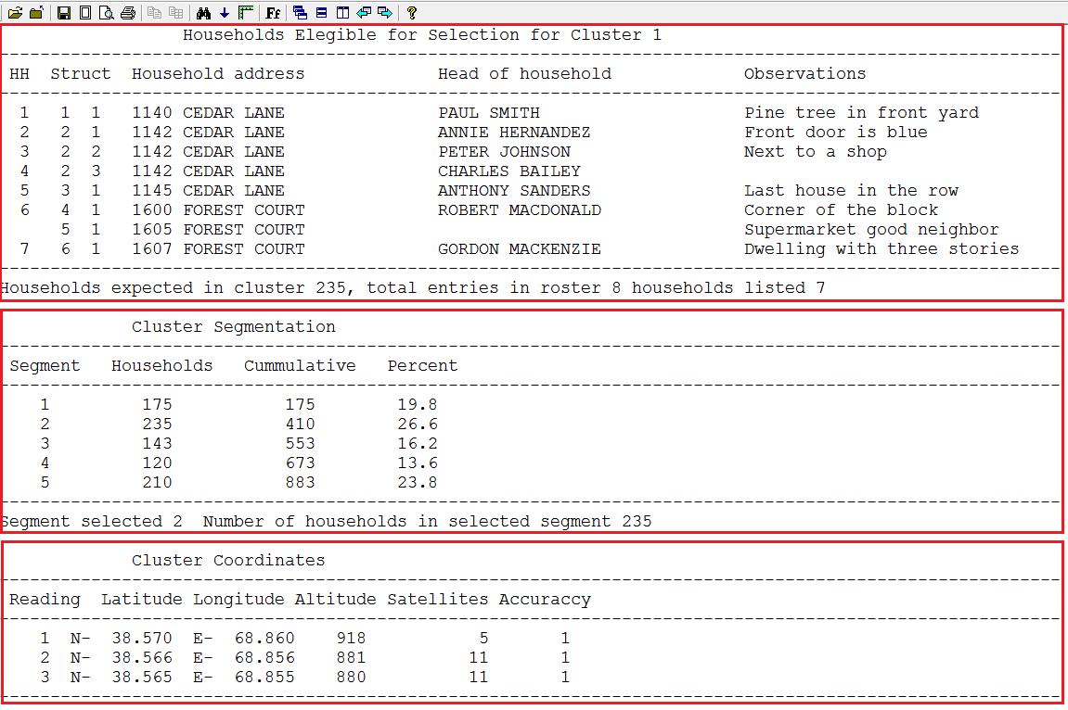

### 3.3.6 Change Cluster Number/Transfer Data to Central Office/Exist the System

The last three options on the HH Listing main menu are self-expalnatory.

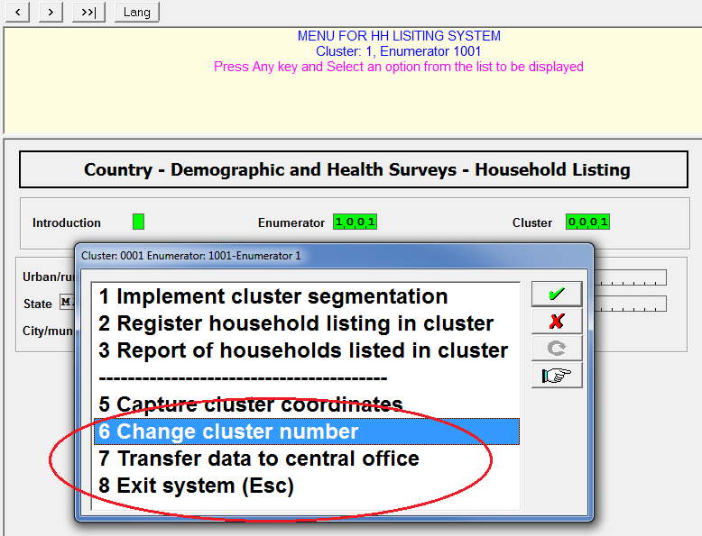

Option 6 (Change cluster number), Moves the cursor back to the **Cluster** field in the main menu form. This option shouldn’t be used frequently because the cluster number should be establsihed upon arrival to a clsuter and it isn’t common to have the same enumerator working concurrently in two clusters. As a good practice it is better to finalize one cluster before moving to another one.

Option 7 (Transfer data to central office). With this option enumerators force the system to send all cluster related data to the central office. DHS uses the Internet File Streaming System (IFSS) to transfer data from the field to the central office. This is done automatically on a daily basis as long as enumerators have access to internet. Nevertheless, it is recommended that as soon as a cluster is declared as finalized they should use this option to send to the central office the updated data. Again, this operation is only possible if the enuerators are connected to internt via modens provided for that purpose or through a WIFI mechanism.

Option 8 (Exit the system). It is very important that enumerators exit the system if they are not expecting to work with it for a prolonged period of time or if they are just taking a break. Like with any other options they can key the number 8, highlight the option and press enter or just press the Escape key. If the system is not exited properly files may not be properly closed and enumerators will get the following two messages next time they access the system.

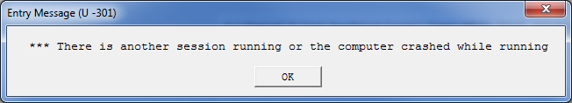

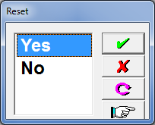

# HH LISTING CENTRAL OFFICE SYSTEM

The main purpose of the central office system is to monitor the HH Listing operation. In order to do that, the system maintains a logging database to keep track of the status for every cluster. The individual assigned to operate this system will be referred in this document as the “Administrator”. It is recommended that the person designated as Administrator is familiar with this type of fieldwork operation. Ideally, the Administrator should also have some familiarity with the country census enumeration areas, as that knowledge is important to decide whether the HH Listing for a cluster is accepted or rejected. The computer where the system is installed requires access to internet because it uses the Internet File Streaming System (IFSS) to download the data being collected in the field.

The Central Office System is set-up in a way that it first accesses the Internet File Streaming System (IFSS). The purpose for this step is to download to the central office designated desktop the data uploaded by enumerators in the field. The DHS data processing expert will provide the Administrator with a user name and password to get access to IFSS.



## 4.1 Analysis of Incoming Files from the Field

Upon login sucessfully, IFSS downloads the data collected by enumerators to the Central Office HH Listing system. Any new or modified files uploaded to the cloud by enumerators are downloaded at this time by the Central office system. The system performs a series of checks and produces a report detaling what was found as shown in the figure below. Three types of findings are reported:

* Number 1, lists information for new clusters that arrived in the central office for the first time. The HH listing for these clusters can be already been finalized or they can be a work in progress. Clusters listed in this report section are logged into the central office database tracking system
* Number 2, three types of transactions are reported here:
  + The first one in green essentially indicates that cluster 1 was listed by two enumerators. The first time that information for that cluster arrived, it was collected by enumerator 1. In today’s run a listing for the same cluster arrived but this time it was collected by enumerator 5. The HH Listing system is designed in such a fashion that a cluster should only be listed by one enumerator. When this problemm occurs, the system displays the content of the problem files and the Administrator should decide wich one is the correct one. Section 4.8 discusses how to resolve the problem once the administrator decides which file needs to be removed.

However, it is also necessary to update the control file with the correct enumerator code. In order to do that the system displays the following screen to select the correct enumerator for the cluster

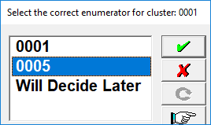

In this case enumerator 0005 was selected and as a result the control file changes enumerator 0001 that was originally registered for the cluster to enumerator 0005. If option **“Will Decide Later”** is selected, no action is taken but eventually a decision has to be made. If an enumerator code is selected, the system displays message 110 to remind administrators to delete files associated to wrong enumerators

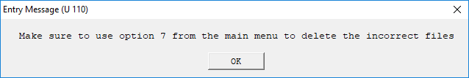

* + The second and third set of problems in yellow and blue, report clusters that had previously arrived but data files for those clusters came again. The reason to have them in two colors is because the ones in yelow correspond to clusters that were already closed by the Administrator. The clusters in blue arrived again but have not been closed by the administrator.
* Number 3, report on clusters that were already revised by the Administrator and he/she considered that they were already finalized and therefore decided to close them. However, for some reason enumerators went back to those clusters and made some modifications. These clusters are also reported in the previous type of problems, but they are listed separatly to emphasize that they were already reviewed by the Administrator. These clusters have to be closed again, but Administrators should use first option 2 to know the type of changes made to the HH Listing entries.

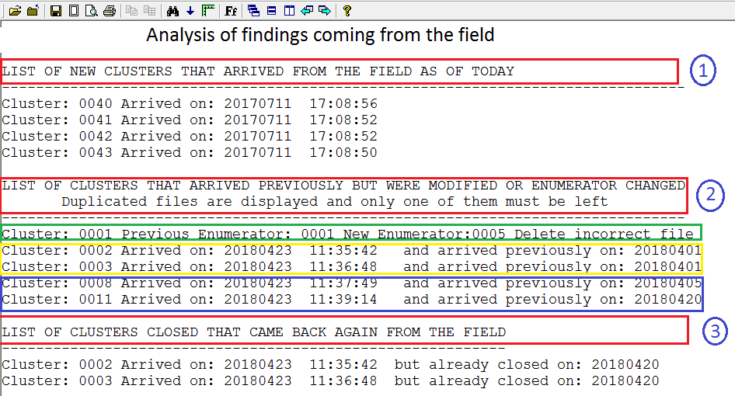

If no new findings coming from the field are found or after reporting one or more of the findings described above, the office system continues to display the menu for the Central Office System.

The form when it is first displayed comes empty and the cursor postions itself in the introduction field. Press the enter/spacebar key and the cursor moves to the cluster field. Some of the tasks to be performed by this system are global to the HH Listing operation, but others are specific to a cluster. Enter a valid cluster number when the cursor reaches that filed. Once that is done, the system populates all geographical fields in the form. If the task to be performed is cluster based, make sure that you have entered the correct cluster by checking the cluster geographical variables.

Let’s now discuss every one of the options avaiable in the menu.

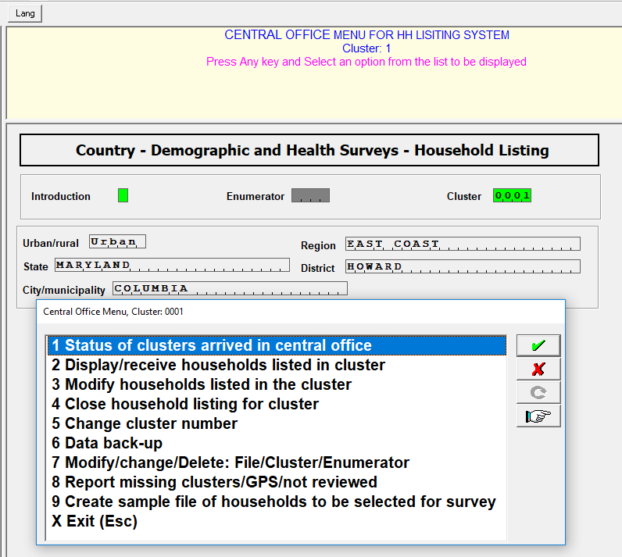

## 4.2 Status of Clusters Arrived in the Central Office

This option produces a status report of the filedwork operation. It will generate one row for evey cluster that have arrived to the central office. The report has the following format:

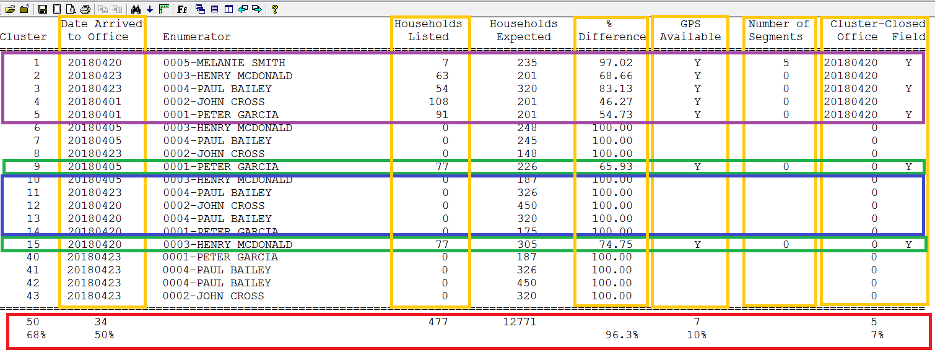

The columns in the report are:

* Cluster - Just the survey cluster number.
* Date arrived to office - This is the date when the cluster arrived for the first time to the Central Office. All clusters in this report at some point have arrived to the Central Office.
* Enumerator - The code and name of the enumerator that visited and reported the cluster the last time. For example, cluster 1 was originally sent by enumerator 1, but the last time it was reported by enumerator 5.
* Households listed – These are the households that were registered for the cluster in the HH Listing system. In order for the system to know how many households are registered, the Administrator should use option 2, as will be described in the next section. Clusters with “0” (zero) households mean that they have arrived but option 2 has not been used for the cluster.
* Households expected – The number of households available from the census or for the segment selected for the cluster, when cluster segmentation was done.
* % Difference – The percentage of the difference between the expected and the actual number of clusters registered for the cluster. The information provided here to calculate the percentages in this example are not real, but in a real operation the closer the percentage is to zero, the better the census/segment records are in the sample frame for the cluster.
* GPS Available – Specifies whether GPS came with the HH Listing data for cluster or not. A blank means that it has not come yet whereas a “Y” means that the GPS data is included as part of the cluster data.
* Number of Segments – If the cluster was segmented, this column displays the number of segments in which the cluster was split. Zero means that no segmentation was done.
* Cluster Closed – This column is divided in two
  + The first (Office), has the date when the Administrator declared the cluster as finalized (closed).
  + The second (Field), has a “Y” when enumerators declared that the cluster was finalized. It is possible that a cluster was declared as finalized in the field, but the administrator has not yet declared the cluster as closed.

Now, let us take a look at the different colors in the report above:

* Purple color – These are clusters declared by the Administrator as closed. They should have values different of zero or blank in the columns: Household listed; GPS available; Number of Segments; and Cluster-Closed (Office). As mentioned in the previous section, it is possible that clusters that were declared as closed comeback again from the field. Administrator should investigate the reason in those cases.
* Green color – These are clusters that arrived to central office, but the Administrator has not declared them as closed. Option 2 has already been used with these clusters, but they have not been declared as finalized by the Administrator. Compared to the previous color of clusters they only miss the Cluster-Closed column and instead in this column the cluster has a value of zero.
* Blue color – These are clusters that have arrived to the office, but option 2 has not been used on them. The only column available for them is the Date Arrived to the Office. Actually, clusters 6 to 8 and 40 to 43 are in this same category, but they were circled in blue to avoid overloading the figure.
* Red color – This is a summary of the entire HH Listing operation. The goal of the entire HH Listing operation is to reach 100% for the columns: Date Arrived to Office, GPS Available, and Cluster- Closed (Office).

## 4.3 Display/Receive Households Listed in Cluster

Option 2 produces a report on the information registered for a cluster by enumerators. Essentially, it lists all entries in the HH Listing system, the segmentation if that was done for the cluster, and the GPS data if it is available. This is one of the options that is associated to a specific cluster. Consequently, when it is used, it is important to make sure that the correct cluster number is present in the “Cluster” field.

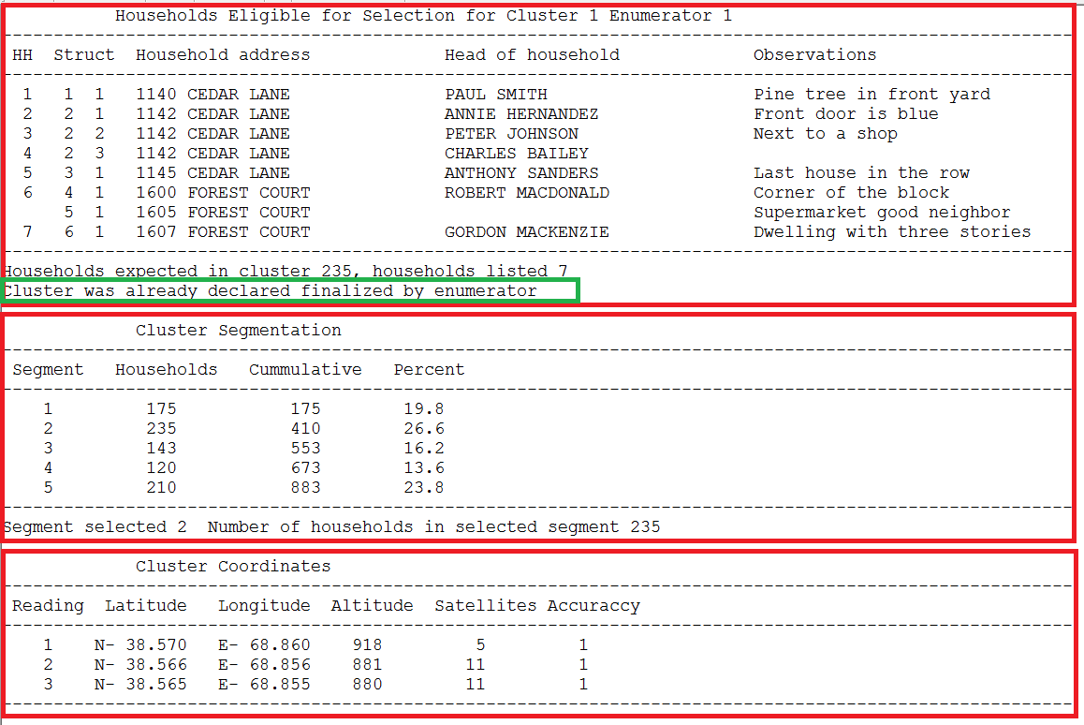

This report is essentially the same as that used by enumerators and described in section 3.3.5 with some small differences. One of the major differences is that this report has a line (in green) to tell the Administrator that the cluster was declared as finalized by the enumerator. If the line is not present, enumerators have not declared it as finalized. It is possible that enumerators forget to declare the cluster as finalized.

When running this option the central office system updates several fields in the clusters tracking database. The following fields: Household Listed; % Difference; GPS Available; Number of Segments; Cluster-Closed (Filed) are updated whenever changes may occur for the cluster. This option can be used as whenever it is necessary to browse the households that were registered for the cluster.

This option provides information useful to the Administrator to be able to declare if a cluster can or cannot be closed. Among them, the number of households expected compared with the number of households listed is a good indication. Another one is if the enumerator declared the cluster as finalized. Of course, there are some built-in controls within the system that may prevent the cluster to be closed as will be discussed later.

## 4.4 Modify Households Listed in the Cluster

Option 3 in the central office system, essentially provides the same functionality as the one described for the HH Listing system for enumerators in section 3.3.3. This option is also associated to a specific cluster. Consequently, when it is used, it is important to make sure that the correct cluster number is present in the “Cluster” field.

Most of the times the Administrator should use this option to correct misspelling errors and potentially to delete or insert new households based on hard evidence.

## 4.5 Close Household Listing for Cluster

Option 4 is used by the Administrator to declare a cluster closed.This option is also associated to a specific cluster. Consequently, when it is used, it is important to make sure that the correct cluster number is present in the “Cluster” field.

To make sure that the Administrator reviewed the households registered for the cluster, it is mandatory that the cluster have used option 2 (Display/receive households in cluster) prior to the execution of this option. The system also requires that the cluster coordinates are present before the cluster can be closed. If the Administrator already closed a cluster, but updated files for that cluster are sent again from the field, after reviewing the nature of the changes, the Administrator has to close the cluster again. In this case, the system displays the following error message.

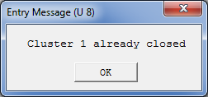

After dismissing this message, the following screen is displayed:

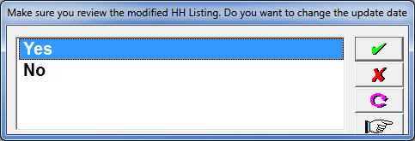

The Administrator should then select “Yes” if that is the action desired. If under the circumstances just described, a closed cluster previously closed with modifications, and this action is not executed, the system keeps reporting this cluster as described for number 3 in section 4.1.

## 4.6 Change Cluster Number

This option allows the Administrator to switch among different clusters without having to exit the system. This is very useful when several clusters arrived and the Administrator wants to browse through several of them.

## 4.7 Data Back-up

Administrators are encouraged to make data back-ups continuously. They should use this option at least once a day, particularly after working extensible with the system. Back-ups are made to flash memory devices. After selecting this option, system prompts to have the flash memory attached to the desktop with the following message.



If after dismissing the message the flash memory is not still attached to the tablet, the system displays the following message



## 4.8 Modify/Change: File/Cluster/Enumerator

Option 7 is used most of the times when two enumerators work on the same cluster. There are two possibilities in this case. The first one that in fact they both enumerators worked on the same cluster and the second that one of them incorrectly registered the households for the wrong cluster number.

If in fact they both worked in the same cluster, it means that the data are duplicated. This problem was described in section 4.1 under Number 2. When that happens, the system lists the content of both files and the Administrator then has to decide to keep one of them and delete the other. Let us assume that the correct HH Listing for the cluster is the one done by enumerator 1, that means that the file generated by enumerator 5 needs to be deleted. After executing option 7, the system displays the “Data Repair” window as shown in figure 1 below. Click on the title “Household Listing Files 2018” and the system displays figure 2. Enter the cluster and interviewer numbers and the double click on the delete button. The system will delete all files associated for cluster 1 and collected by enumerator 5.

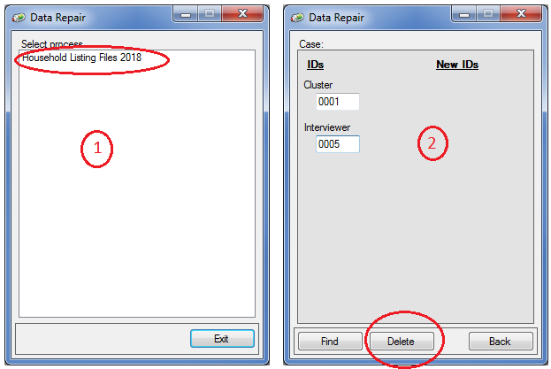

If on the other hand enumerator 5 incorrectly specified that he was working in cluster 1 when in fact he was working in cluster 10, then what needs to be changed is the cluster number.

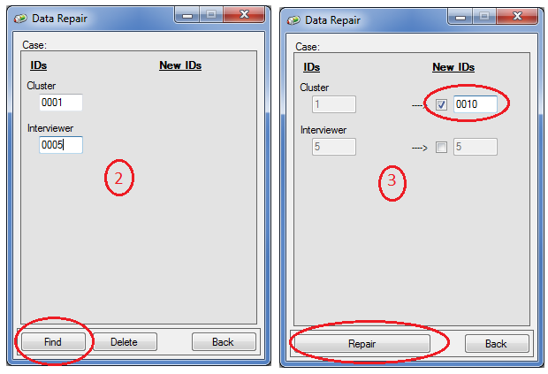

Once figure 2 is displayed and after keying the cluster and enumerator numbers, press the find button. The system then displays figure 3. Under column New IDs, select the box for cluster number and type the desired cluster (in this case 0010). Double click on the Repair button and all information related to cluster 1 enumerator 5, will be changed to cluster 10, enumerator 5. This type of change can also be made if for some reason it is the enumerator number that was incorrectly used.

## 4.9 Report Missing Cluster/GPS/Not Reviewed

This report is just another tool available to Administrators to get a picture of the fieldwork operation. Essentially, the report is intended to show pieces of information missing or steps still necessary to carry out to fully process a cluster.

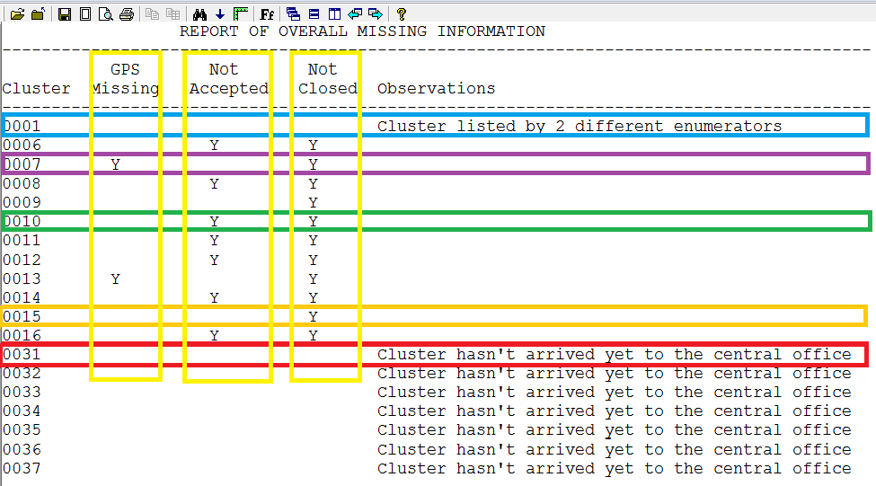

There are several type of issues that can be observed in the report as highlighted by the different colors. The highlight is only done for one cluster to avoid overloading the report, but most cases the same applies to other clusters.

* The first characteristic is that if the cluster is not listed here, that means that it was already successfully processed (closed). For example, the Administrator successfully closed clusters 2 to 5 and therefore they are not listed here.
* Cluster 1 in blue reports that information for that cluster arrived from two different enumerators. As discussed previously this is a mistake and needs to be fixed as explained in section 4.8.
* Clusters 10 in green (also included in this category are clusters 6, 8, 11, 12, and 16), arrived to the office but the administrator has not reviewed them (option2 of the main menu for those clusters has not been used). As a result, there is a “Y” under column “Not accepted” and of course a “Y” in column “Not closed”
* Cluster 7 in purple (applied also to cluster 13), arrived to the office, were reviewed by the Administrator, but the information for GPS hasn’t yet arrived. Consequently, the blank under column “Not Accepted” and the “Ys” under “GPS Missing” and “Not Closed”.
* Cluster 15 in magenta (also applied to cluster 9), arrived to office, were reviewed by the Administrator, the GPS data for them also arrived but the Administrator has not closed them yet. Consequently, the blanks under “GPS Missing”, “Not Accepted” and the “Y” under “Not Closed”.
* Cluster 31 (also applied to clusters 32 to 37) as documented under observations have not arrived to the office yet. Note that these clusters are listed at the end to conveniently browse the report

## 4.10 Create Sample File of Households to be selected for the Survey

Option 9 is not available to Administrators. It is intended for DHS data processing or sampling specialists. It is used to draw the sample of households to be included for each cluster in the survey. This option should be used at the end of the HH Listing operation. It generates the file required by the DHS CAPI data collection system to identify the households to be visited during the survey’s fieldwork operation.

## 4.11 Exit (Esc)

Option X (Exit the system). It is very important to properly exit the system when the Administrator is not present around the desktop where the system is installed. Like with any other options they can key the the letter X, highlight the option and press enter or just press the Escape key.